Data Analysis for Robo-Advisors

University of Essex
Department of Economics
The Rise of Robo-Advisors: A Quantitative Analysis of Digital Portfolio Strategies

Data Analysis: 4 Prominent Robo-Advisors and constituent ETFs

Supervisor: Professor Sheri Markose

Gaurav Kukreja
Date: Dec 2022

Table of Contents
1 Introduction 2
2 Market Capitalization 3
2.1 Growth of Market cap at the start and end of the period 3
2.2 Market Cap Evolution 4
3 Arbitrage and ETF Categorization 6
3.1 Arbitrage and available data 6
3.2 Categorization of ETFs in relation to arbitrage 6
4 Mispricing and Arbitrage 9
4.1 Mispricing and its view for all ETFs 9
4.2 Top 12 ETFs by Market Cap 11
4.3 Low 11 ETFs by Market Cap 12
4.5 Individual ETFs and Robo-Advisors 14
5 Bid/Ask Spread 16
5.1 Bid/Ask Spread for Top 12 ETFs by Market Cap 16
5.2 Bid/Ask Spread for Low 11 ETFs by Market Cap 17
5.3 Bid/Ask Spread and ETF Price Return 17
6 Short Interest 19
6.1 Short Interest for Top 12 ETFs by Market Cap 19
6.2 Short Interest for Low 11 ETFs by Market Cap 19
6.3 Short Interest and ETF Price Return 20
7 Rebalancing 22
References: 23
Appendices: 24
Appendix A: Descriptive Statistics 24
Appendix B: Arbitrage plots for each Robo-Advisor 24
Appendix C: Mispricing (Price minus Net Asset Value) plots for each Robo-Advisor 26
Appendix D: Bid/Ask Spread plots for each Robo-Advisor 28
Appendix E: Short Interest % plots for each Robo-Advisor 30

1 Introduction

This section introduces all the ETFs under an aggressive portfolio of 4 leading Robo-advisors, i.e., Wealthfront (WF), Betterment (BM), WiseBanyan (WB) and SigFig (SF). Table 1 provides a high-level snapshot of each ETF, including the asset class of their underlying securities and corresponding allocation/weights by relevant Robo-advisors. As can be seen, the lion’s share of 89.5% is allocated to equity represented by 10 ETFs, out of which 2 invest in developed markets (26%) and 2 in emerging markets (15.93%). That is followed by Bonds (10.3% under 12 ETFs) and remaining by REIT (Real Estate Investment Trust, 0.2% under 1 ETF).

Table 1: A Snapshot of 23 ETFs under 4 Robo-Advisors’ Aggressive Portfolio between 2nd Jan’14 to 30th Aug 2019
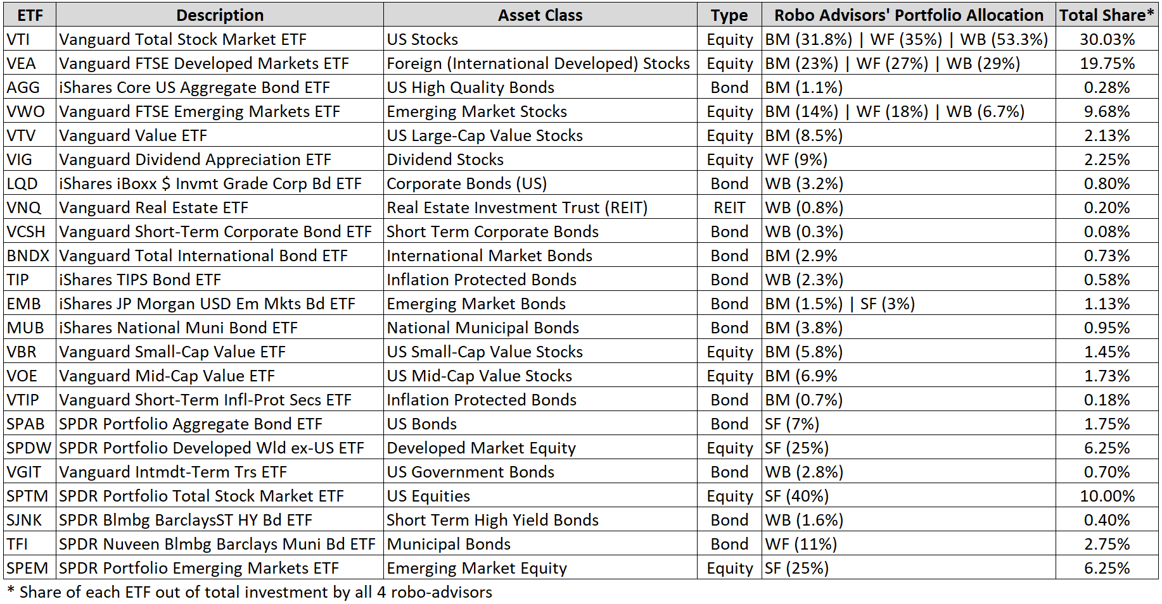

The Vanguard’s dominance is notable that manages 12 of these 23 ETFs, which obtains a significant share of 68.88% of the total allocation. That is followed by SPDR, managed by State Street Global Advisors consisting of 6 ETFs and 27.4% allocation. The remaining 5 ETFs are managed by Blackrock (denoted as iShares), attaining 3.73%. From an angle of Robo-Advisors’ investment approach, WF is vested with 4 Equity and 1 Bond ETF. BM invests with 6 Equity and 5 Bond, followed by WB (5 Bond, 3 Equity and 1 REIT) and SigFig (3 Equity and 2 Bond).

The daily time-series data for each ETF is pulled from the Refinitiv Eikon tool (a London Stock Exchange company) via API. The variables include Closing price, market cap, outstanding shares, net asset value (NAV), best ask, best bid, and short interest percent. It is adjusted with some of the information obtained from ETF sponsor’s websites, where found appropriate, to improve accuracy.

2 Market Capitalization

2.1 Growth of Market cap at the start and end of the period

The bar chart in Figure 1 below depicts the market cap at the beginning (02/01/2014) and end of the period (30/08/2019) across all ETFs, in descending order at a latter date. The opening average of all ETFs for the period stands at $9.7B, which rises significantly to $27B at the close. The starting and closing median ETF is ‘EMB’ which values $3.5B and $16B, respectively. Barring the lowest 7 ETFs in Jan 2014, the rest have a market cap of at least $1B. The top 3 (bottom 3) ETFs, i.e., VWO, VTI and VIG (VGIT, SPEM and SPTM) at the start of the period range between $19.3B and $45.3B ($119M - $574M). The VWO and VIG rank down (VGIT and SPTM rank up) during this period, and the top 3 (bottom 3) are joined by VEA and AGG (TFI and SJNK), that fall in the range of $66B and $118B ($2.5B - $4.4B) in Aug 2019. The largest growth of 3549% is witnessed by VGIT, followed by BNDX (2384%) and SPEM (965%). The least growth is experienced by SJNK, which shrank by 2%, followed by VWO and TIP (34% and 62%).

Figure 1: Growth of Market Capitalization for ETFs under the purview
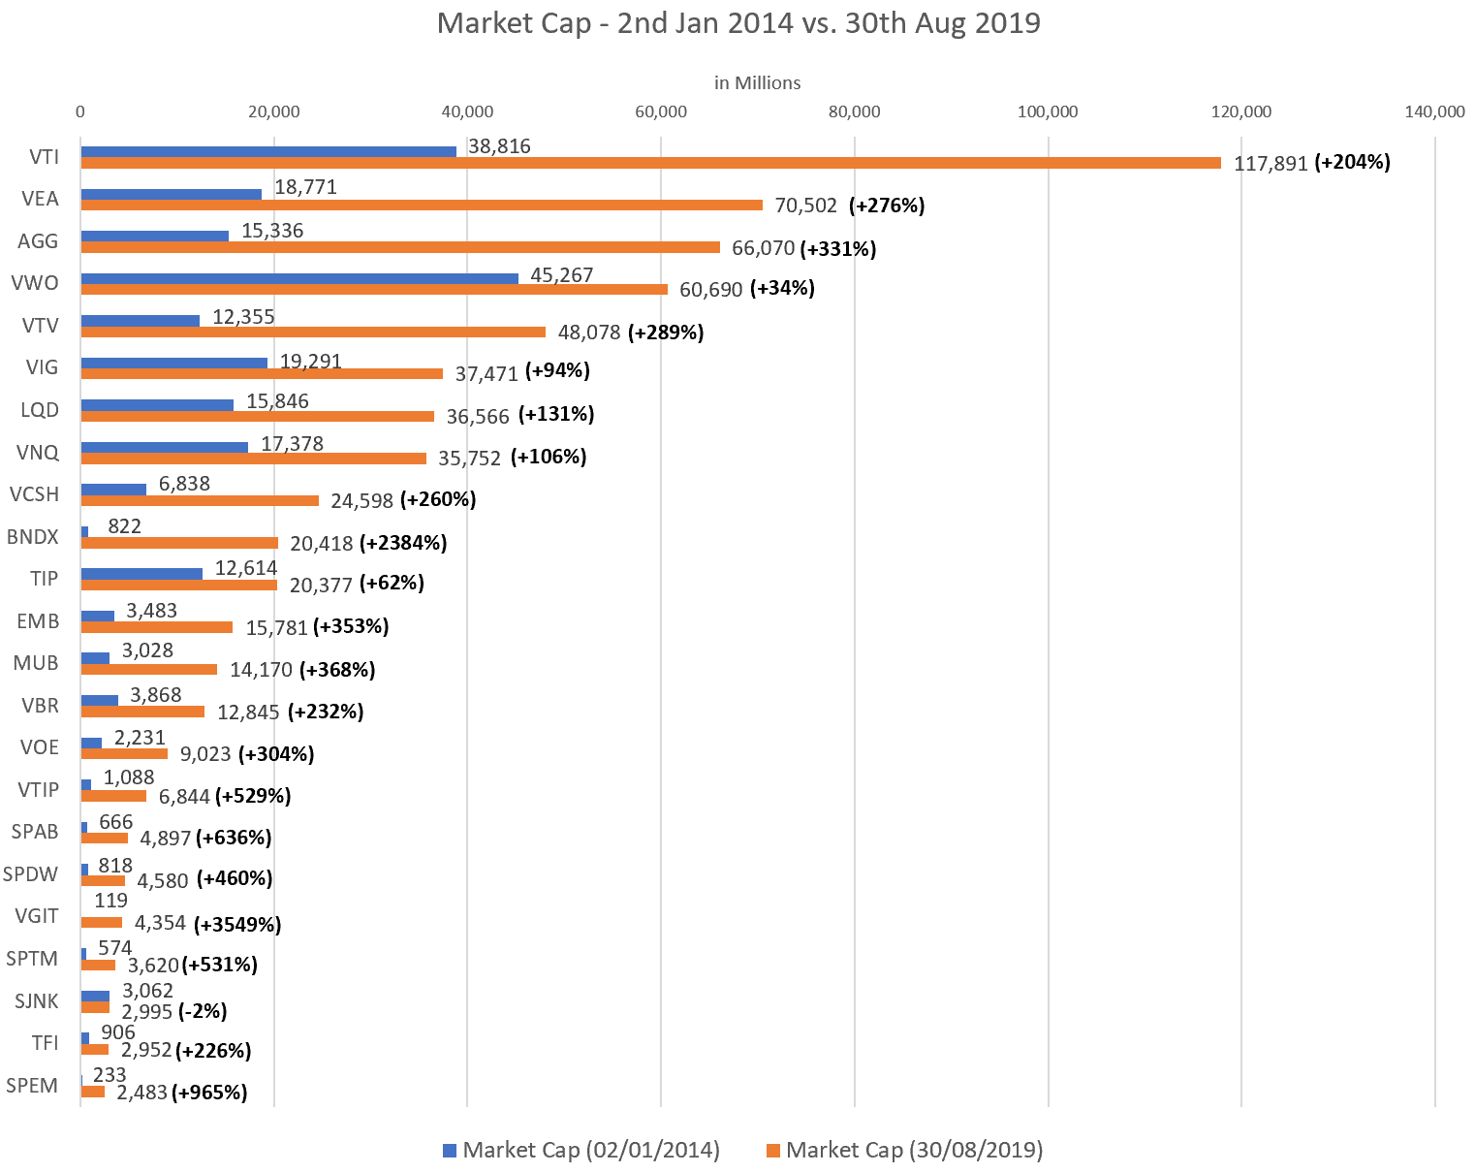

2.2 Market Cap Evolution

For a convenient view, ETFs are divided into top 12 and low 11 by market cap as of Aug 2019. The trajectory of their growth can be seen in Figures 2 and 3 below. The top 12 contain 6 ETFs of Bond type, 5 of equity and 1 as REIT. They range from a minimum of $16B for EMB (emerging market bond) to the highest of $117B for VTI (US Stocks). The VTI surpassed VWO after about 200 days and maintained its dominance since then, which grew by 204%. The top 3 by percentage growth are BNDX, EMB and AGG. Although they all belong to the bond type, BNDX, in particular, is notable for its remarkable growth of over 2300% associated with the international market. The lowest 3 by percentage growth are VWO, TIP and VIG, adding up only under 100%. The lowest is VWO, whose underlying is emerging market stocks.

Figure 2: Top 12 ETFs by market cap as of 30th Aug 2019, that ranges from min of $16B (EMB) to highest $117B (VTI)
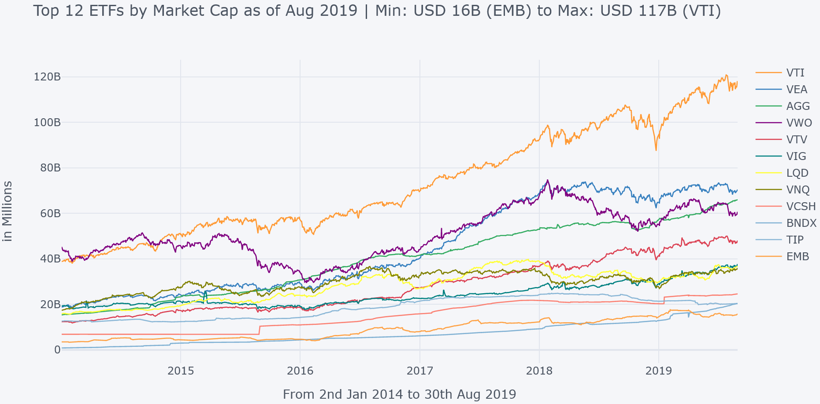

The low 11 in Figure 3 contains 6 ETFs of Bond type and 5 of equity ranging from a minimum of $2.5B for SPEM (emerging market equity) to the highest of $14B for MUB (national municipal bonds). The VBR (US small-cap value stocks) started with the highest market cap in absolute terms but was surpassed by 2nd biggest MUB towards the end. The top 3 by percentage growth are VGIT, SPEM and SPAB. The VGIT is worth highlighting for its extraordinary growth of over 3500%, whose underlying is US Government bonds. The lowest 3 by percentage growth are SJNK, TFI and VBR to add up to under 250%. The lowest is SJNK which shrank by 2%.

Figure 3: Low 11 ETFs by market cap as of 30th Aug 2019, that ranges from min of $2.5B (SPEM) to highest $14B (MUB)
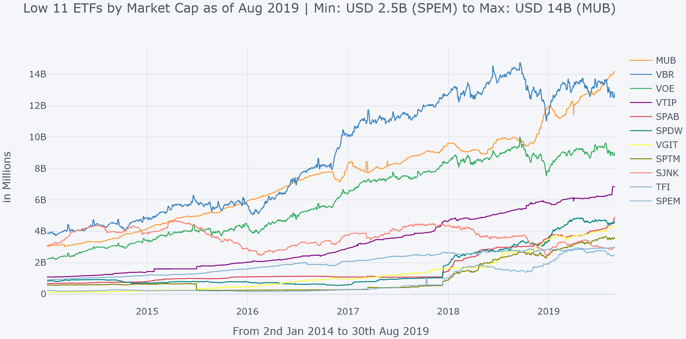

3 Arbitrage and ETF Categorization

3.1 Arbitrage and available data

In simple terms, arbitrage is defined as an exploitation of different prices available in the market(s) for the same instrument or their underlying(s) due to their nature of convergence at a later time (usually in milliseconds but could be prolonged for several reasons). The arbitrageurs play a key role in eliminating mispricing. Although most arbitrage activity is conducted in the secondary markets (mainly exchanges), a lower bound happens in the primary market by way of creation (redemption) of ETF shares which institutional investors facilitate called authorized participants (aka AP), who are typically market makers or specialists. They are authorized to transfer underlying securities of an ETF to the issuer and request bundling them into an appropriate number of ETF shares. This process is called ETF share creation. Conversely, they can seek underlying securities in an exchange of ETF shares called redemption. The secondary market demand and supply dynamics often diverge the ETF prices from the value of underlying securities (net asset value or NAV), providing an opportunity for APs. For instance, when the ETF price is higher than its NAV, an AP may short-sell ETF shares in an exchange and buy underlying, which they proceed to provide to the ETF sponsor in exchange for an appropriate number of ETF shares (creation). In a reverse scenario, they may buy ETF shares, sell underlying on an exchange, and proceed to the issuer for underlying securities in exchange for ETF shares (redemption) [2]. Such a process changes the number of outstanding ETF shares used to define an arbitrage activity in this study.

3.2 Categorization of ETFs in relation to arbitrage

Brown et al., 2016 classify ETFs into 2 categories based on the below criterion.
“(i) a sample in which funds' market capitalizations exceed $50M, and
(ii) a sub-sample of (i) in which funds are included after the first date on which one-half of the trading days within a month experienced some share creation/redemption activity.”

As covered in the earlier section, all the ETFs under Robo Advisors easily meet the criteria (i). All ETFs have a market cap of over $50M+ at any given time during the time interval of our study. Moreover, all of them are mature ETFs, too, meeting criteria (ii) at some stage. Table 2 shares some important information about ETF’s arbitrage activity in contrast with the corresponding market cap. It (and any following ETF table in this paper) is sorted in descending order by market cap at the end of Aug 2019. The description of some of the information is as follows. Any number (if not specified) is for the period of study (Jan’14 – Aug’19).
- The market cap at the start and end is presented along with their growth in columns 2, 3 and 4.
- As per Brown et al., 2016, an ETF enters a mature category when more than 50% of the (business) days in a month carry an arbitrage activity. That first month is shown under column 6. Some ETFs that achieved this status beyond the first year (2014) are highlighted in bold.
- The total number of months (business days) is shown in column 7.
- Each ETF’s number of months with arbs activity and its total percentage is presented in columns 8 and 9.
- Columns 10 and 11 highlight the number of days with the creation of shares (positive change in shares outstanding) and redemption (negative change).
- In column 12, how much additional creation over redemption activity is presented in percentage, computed as column 10 divided by 11 minus 1.
- The Authorized Participants (APs) usually engage in the creation and redemption of at least 10,000 shares. Thus, the daily arbitrage activity is only considered when there is a change of at least 10,000 outstanding shares in a day (the denominator in computation below).

$$Arbitrage_{t}=\frac{Shares Outstanding_{t}-Shares Outstanding_{t-1}}{Shares Outstanding_{t-1}}*100, where t represents a day$$

Table 2: ETFs, market cap growth, portfolio allocation, and creation (redemption) numbers
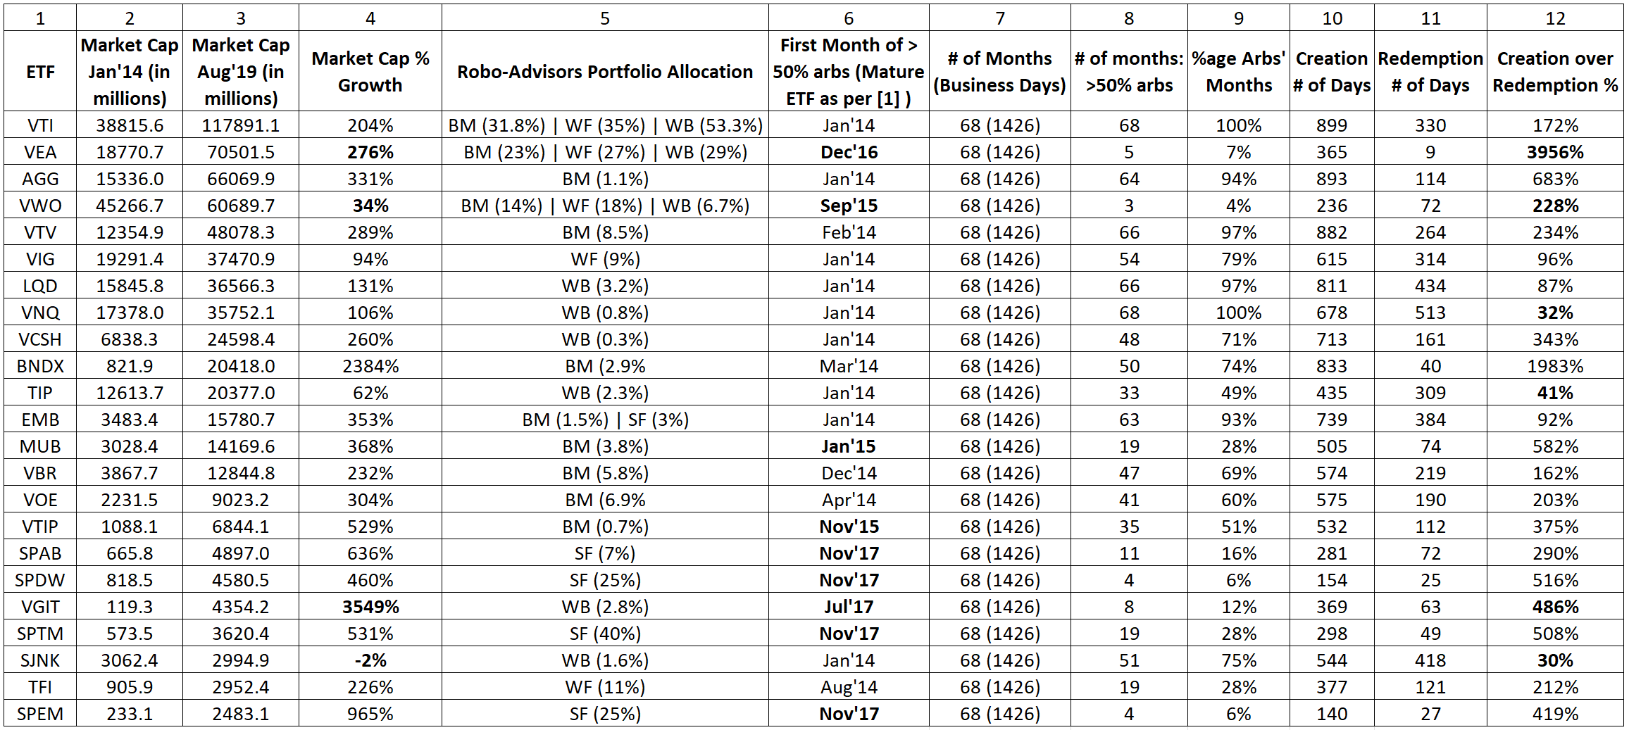

As seen in column 6, many ETFs achieved mature status beyond the first year, including some of the top ones by market cap, such as VEA and VWO. That is further reflected in column 8, with a mostly much lower number of months with arbs activity relative to others. They do not specifically represent any asset class (or ETF sponsor) and carry a mixture of bond and equity (4 Bond and 5 equity). A glimpse over columns 10 and 11 shows a clear pattern of much more shares’ creation activity than redemption across ETFs. Among some noteworthy observations, VWO has 228% additional share creation, whereas the market cap only rose by 34%. VNQ, TIP and SJNK (all bond types) experience quite low additional creation well under 50% (2 fall under the inflation-protected category). The market cap of SJNK rather shrank over the period. VEA has 3956% additional creation with relative meagre growth in market cap. It only observed arbs activity for 7% of the total days (1426) with only 9 redemption days, which is highly skewed towards creation. Conversely, VGIT witnessed 486% additional creation; however, its market cap rose significantly higher by 3549%.

The above analysis is complemented by Table 3, which shows an average of shares creation and redemption, alongside the count of their occurrence. It is not a daily average and excludes days when no arbs activity happened. Any outlier (over 25% daily share change), is ignored to account for shares adjustments or any other data anomaly. This approach is followed throughout further data analysis in upcoming sections. The top 3 numbers are highlighted in bold and the bottom 3 in bold & italic. As can be seen, the maximum share creation on any given day took place with VTV, VIG and VSCH and the bottom 3 with EMB, MUB, and TFI. The highest 3 average creation range from 1M to 3.8M shares, that are experienced by VEA, VWO and SPDW (representing developed and emerging market equity). The lowest 3 are MUB, VOE, and VGIT, each under 260k shares. On the redemption side, the maximum 3 on any given day are observed by VEA, VIG and TFI, and the bottom 3 are VCSH, MUB, and SPEM. VEA, VWO and LQD see the highest 3 averages between 1.4M – 8.3M shares. The lowest 3 are VOE, VTIP, and VGIT.

Table 3: Some Stats on Share Creation and Redemption
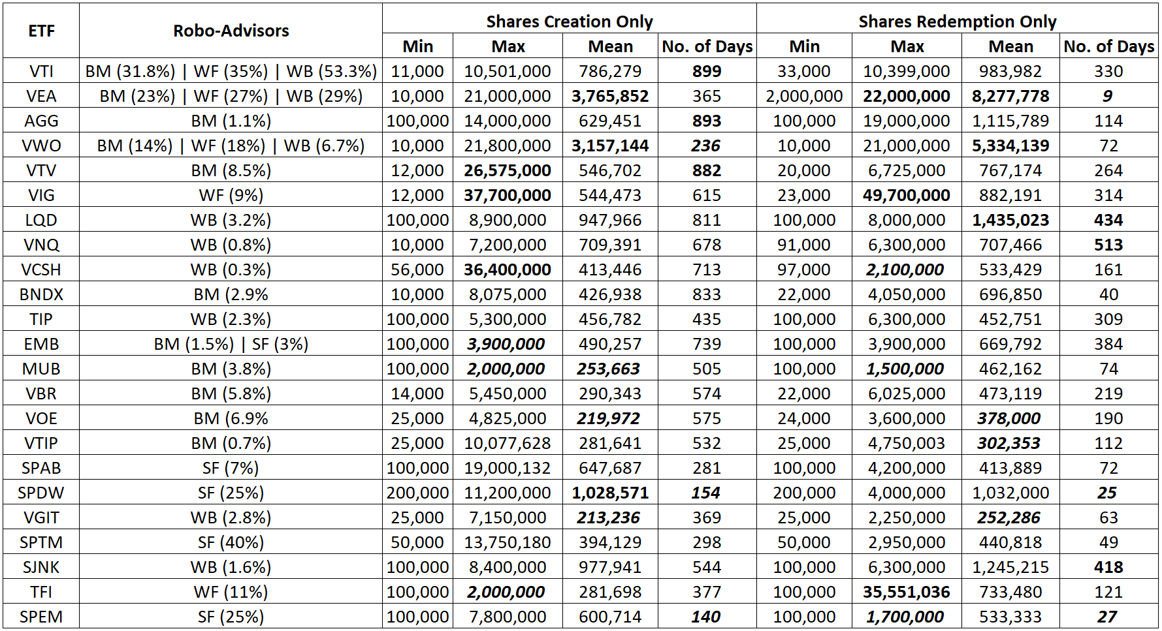

4 Mispricing and Arbitrage

4.1 Mispricing and its view for all ETFs

It is a discrepancy between ETF price and net asset value (NAV) of its underlying securities and computed as price minus NAV. In an ideal world, both should sync at all times with the role of arbitrageurs to make a profit. Thus, any such opportunity vanishes quickly; however, it sometimes may persist for longer when their capital gets scarer and trading costs to increase [2]. It is computed as a percentage over daily closing price, as defined below, for analysis purposes.

$$Mispricing_{t}=\frac{ETF price_{t}-Net Asset Value_{t}}{ETF Price_{t}}*100, where t represents a day$$

A view of it can be seen in Figure 4 for all 23 ETFs, where it appears to be symmetrical. In other words, the higher ETF prices than NAV are followed by lower prices in the same proportion and vice versa. It also implies that the existence of mispricing is subsided by the actions of market participants, including APs, which puts pressure on the other side. This notion can be observed with the close average values (0.15% and -0.13%) on the positive (P>NAV) and negative (NAV>P) sides. They do not consider certain days when mispricing does not exist. The average of absolute values on both sides considers each day which comes to about 0.13%. The mispricing range mostly lies within +/- 1%, and the standard deviation is 0.22%. Some important events and their corresponding impact on the mispricing can also be observed.

Figure 4: Mispricing (Closing price minus NAV) plot for the period of Jan 2014 to Aug 2019
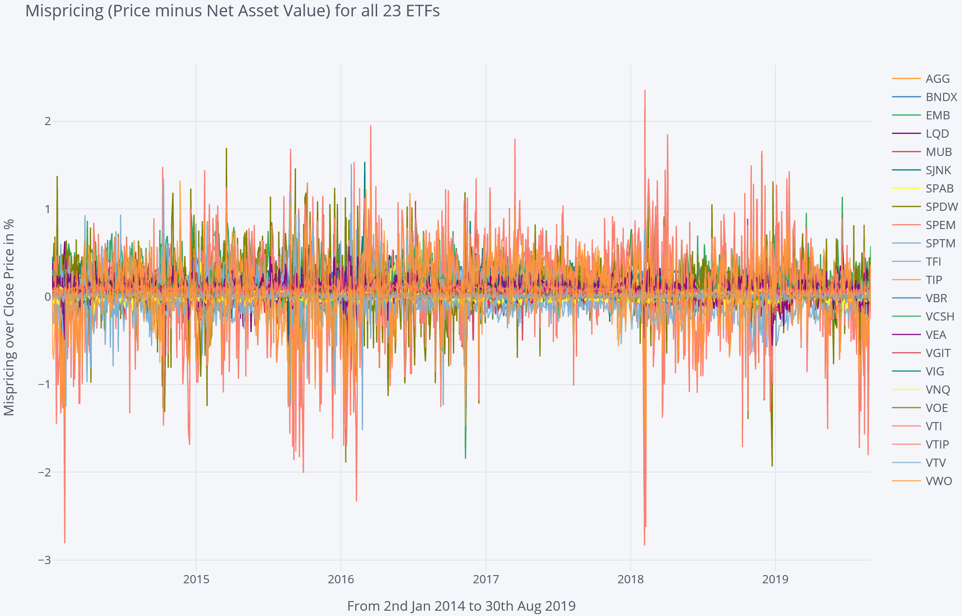
Abs Mean: 0.13%
Std Dev: 0.22%
Pos (P > NAV) Mean: 0.15%
Neg (NAV > P) Mean: -0. 13%
Flash Crash: 24/08/2015
Brexit Referendum: 23/08/2016
VIX Spike: 06/02/2018

Figure XX: Average Mispricing for all 23 ETFs (Jan 2014 to Aug 2019)
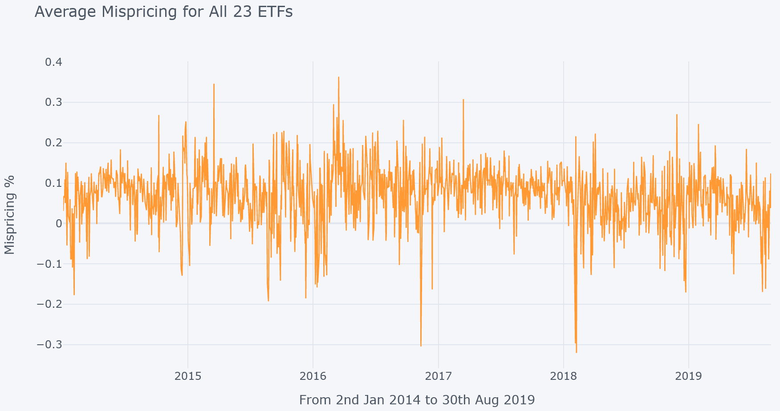

The plot looks dense due to limited space for 23 time-series data and can be mistaken for a higher average for mispricing. Thus, it is complemented with frequency distribution in Figure 5, where the concentration of the same data points can be seen as close to 0. It indeed looks symmetrical, and the overall average stands at 0.07%.

Figure 5: Frequency Distribution of Mispricing (Closing price minus NAV) for all ETFs (Jan 2014 to Aug 2019)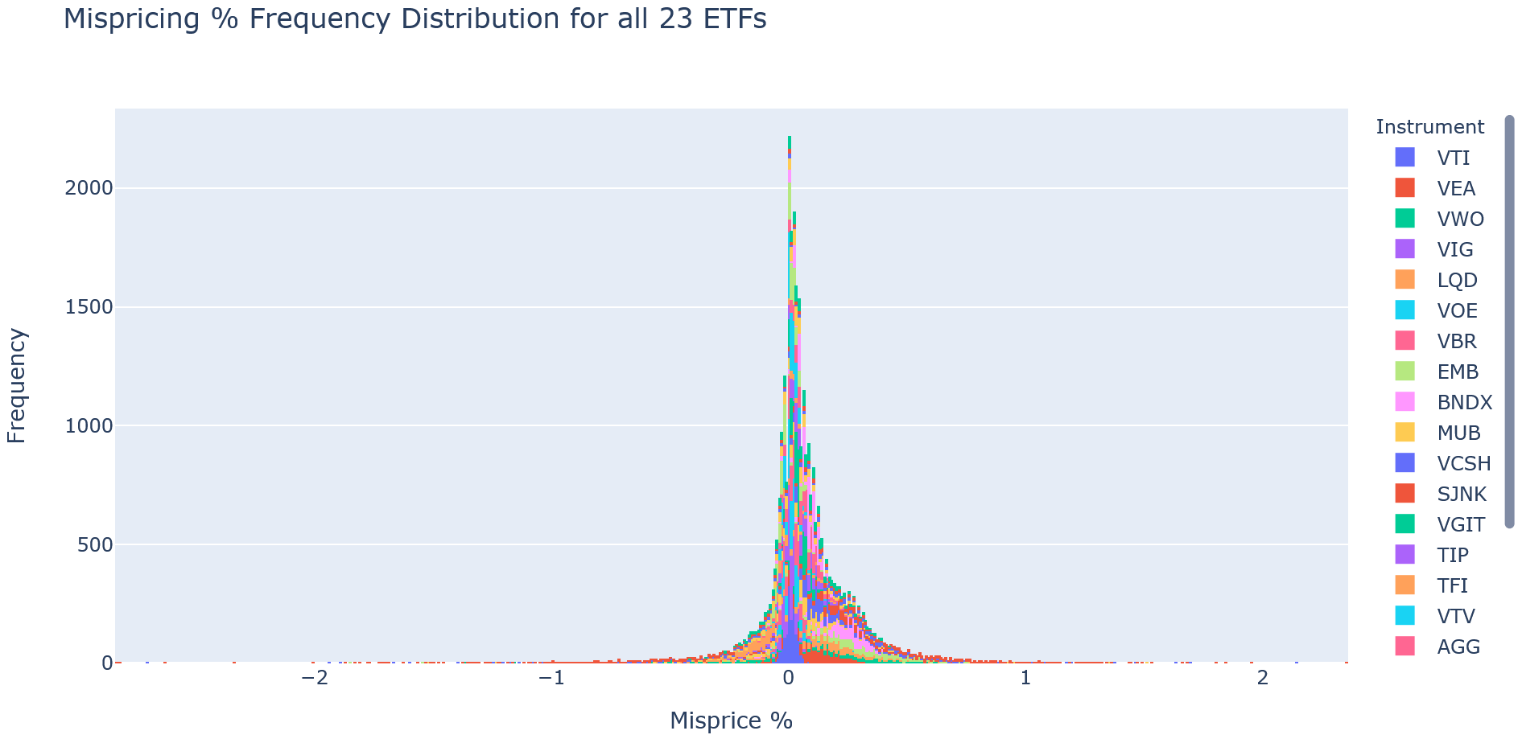
Mean: 0.07%

It is worth comparing mispricing distribution with arbitrage to observe any potential similarity or pattern. A plot in Figure 4 displays shares creation/redemption activity. It is represented as a percentage of share change over outstanding shares for the previous day, excluding any outlier beyond +/-25%. It seems to vary by ETFs, and spikes are found throughout the period as the arbitrage activity facilitated by APs does not occur every day, and some days show higher than others depending on the arbitrage opportunity. There is no clear pattern found on its own. The average for share creation over the previous day is 0.45%, whereas the same for redemption activity is -0.56%. The overall average for absolute values stands at 0.23%. To identify a potential significant pattern, further subsection breaks down the data points for 23 ETFs into sub-groups of top 12 and low 11.

Figure 6: Arbitrage (Shares Creation or Redemption) plot for the period of Jan 2014 to Aug 2019
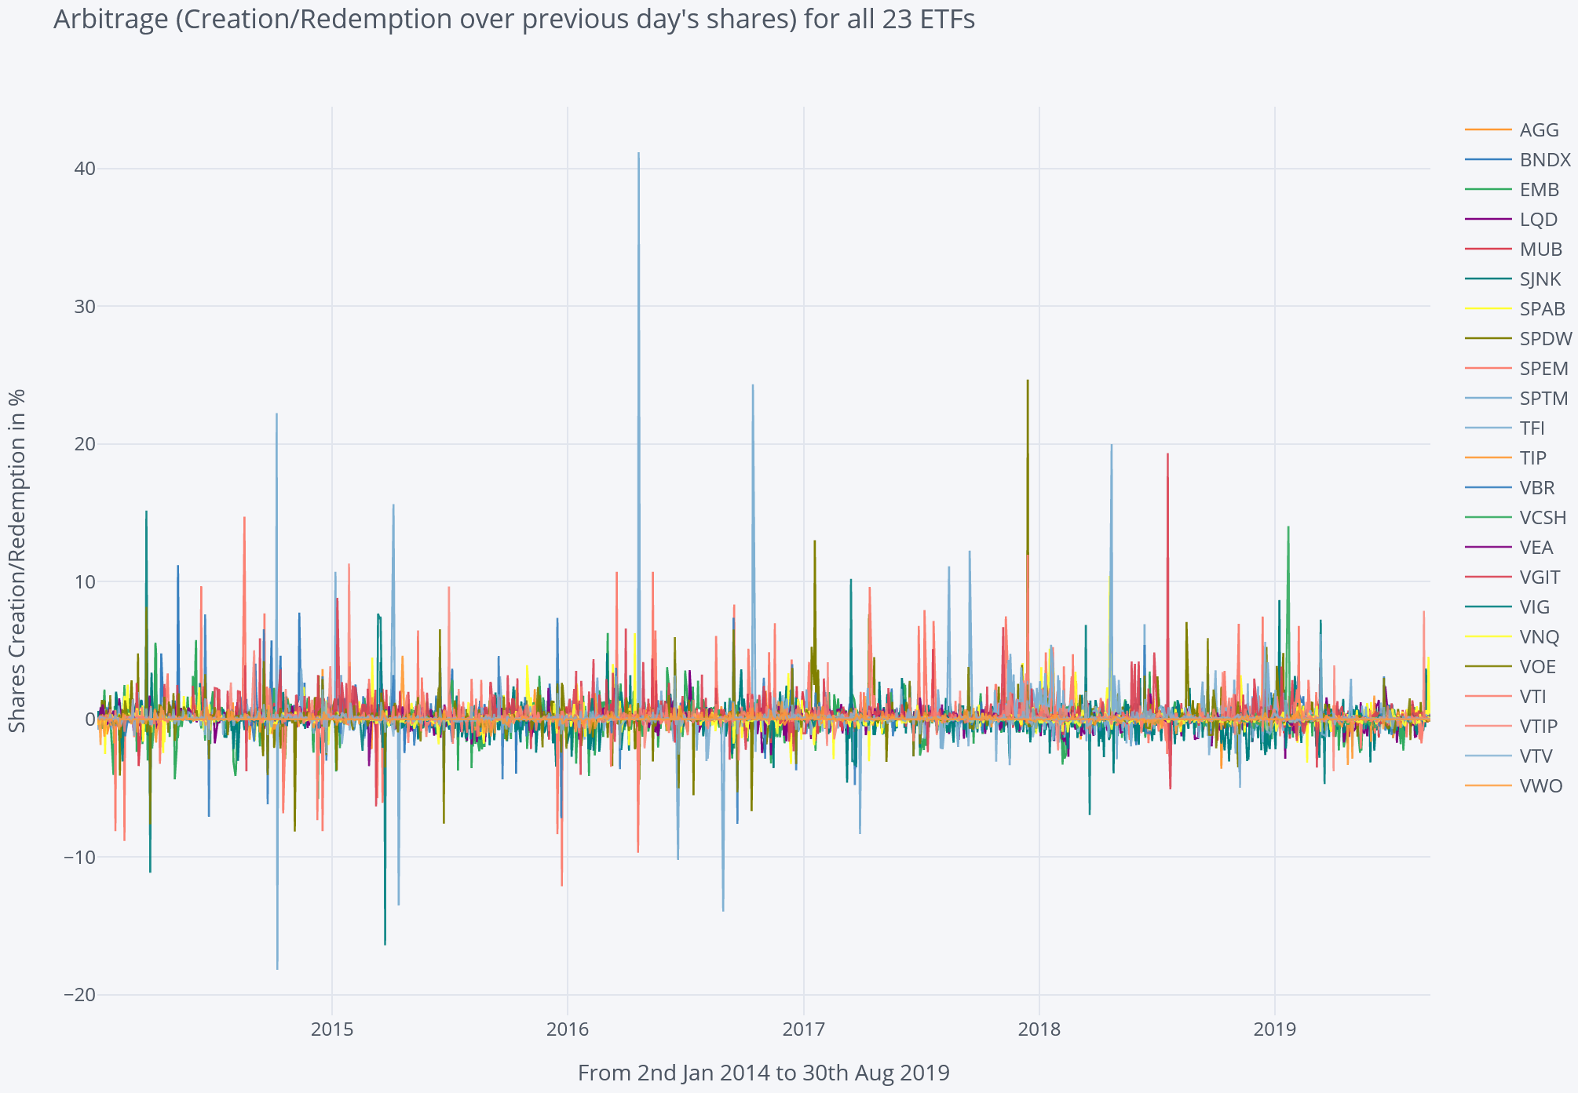
Abs Mean: 0.23%
Std Dev: 0.78
Positive Mean: 0.45%
Negative Mean: -0.56%

Figure XX: Average of Arbitrage for all 23 ETFs (Jan 2014 to Aug 2019)
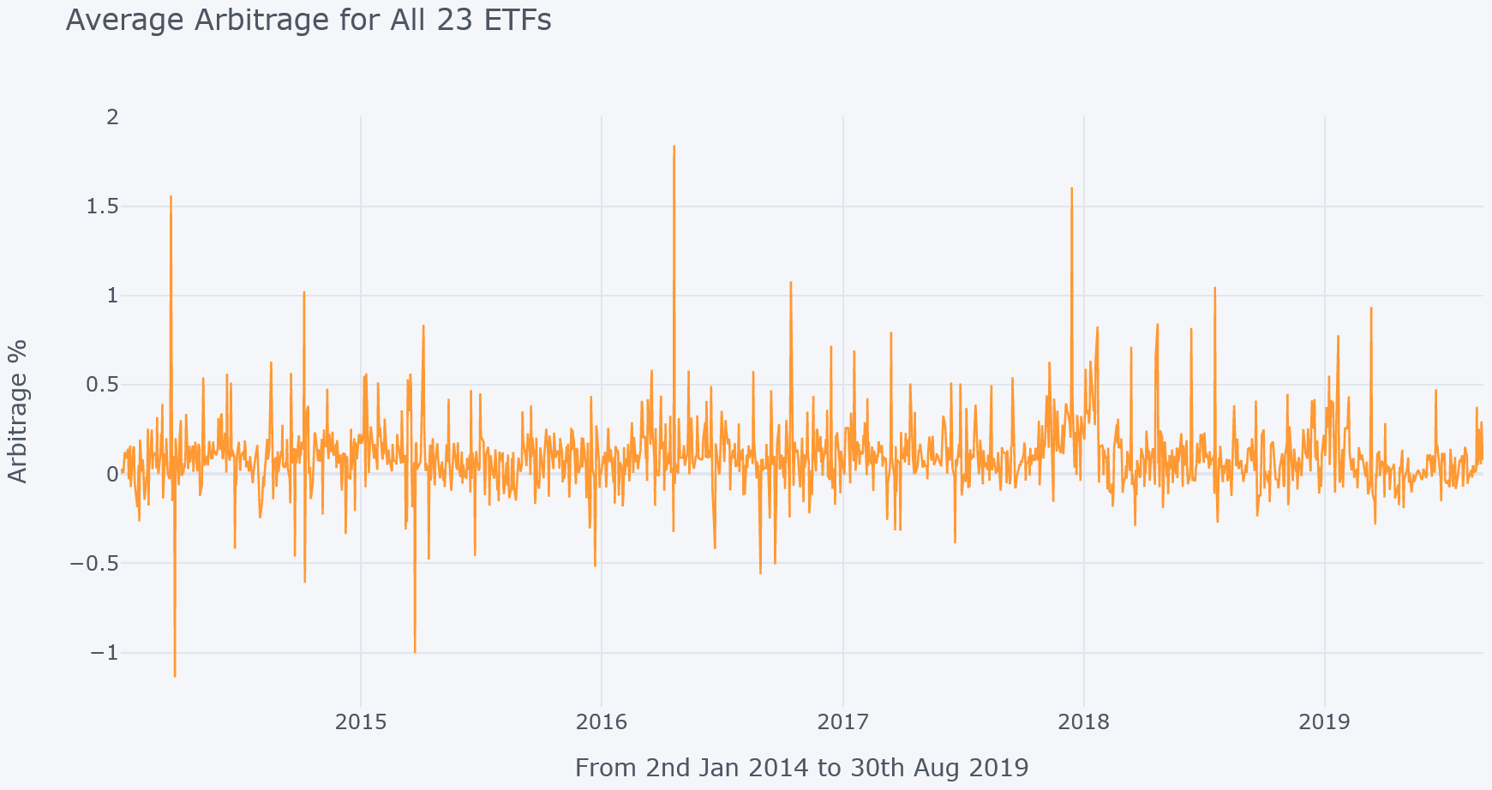

4.2 Top 12 ETFs by Market Cap

The mispricing for the top 12 ETFs by market cap is shown in Figure 7 where it appears to follow a similar trend as for all ETFs in Figure 4 though there are a couple of differences. The NAV and ETF price deviation is relatively tighter at 0.17% (vs 0.22%). The negative mean (where NAV > P) is -0.09% (vs -0.13%) which suggests that NAV does not exceed ETF closing price often. The absolute and positive mean are quite close.
The arbitrage for top 12 ETFs by market cap is shown in Figure 8, where most of the movement lies within the range of +/- 2%. The spikes found are relatively less than all ETFs combined, as in Figure 6, which shows more regular arbitrage activity, demonstrated by summary statistics. The mean on shares creation (redemption) is 0.29% (-0.39%) in comparison to overall average of 0.45% (-0.56%). It also varies less than overall (a standard deviation of 0.52 vs 0.78). Although the absolute mean is less too (0.20 vs 0.23), the difference may not be significant compared to other statistical measures.

Figure 7: Mispricing (Closing price minus NAV) for Top 12 ETFs by market cap (Jan 2014 to Aug 2019)
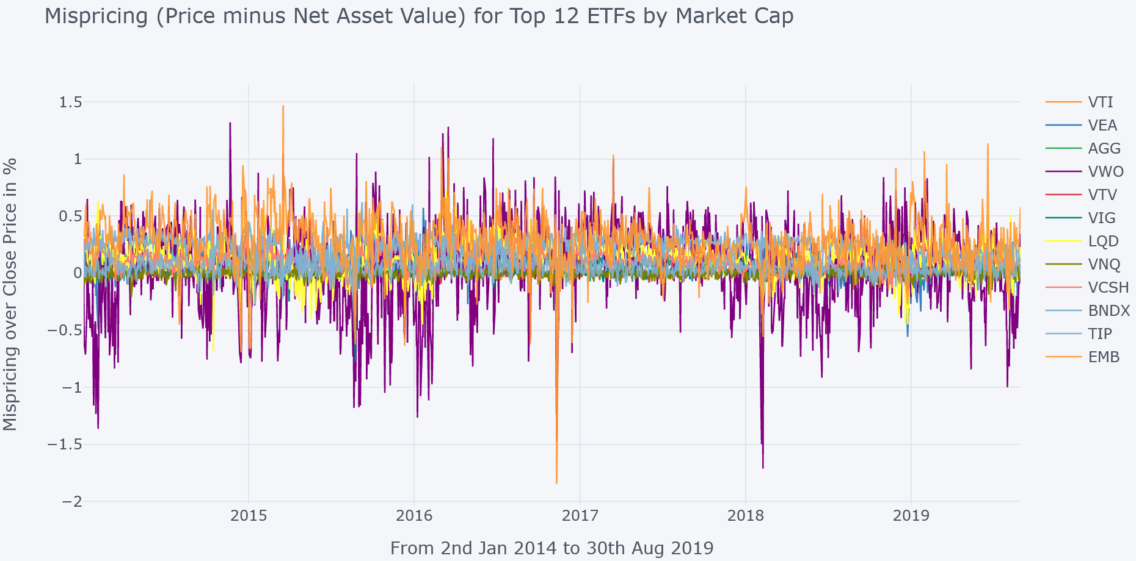
Abs Mean: 0.13%
Std Dev: 0.17%
Pos (P > NAV) Mean: 0.15%
Neg (NAV > P) Mean: -0. 09%

Figure 8: Arbitrage (Shares Creation or Redemption) for Top 12 ETFs by market cap (Jan 2014 to Aug 2019)
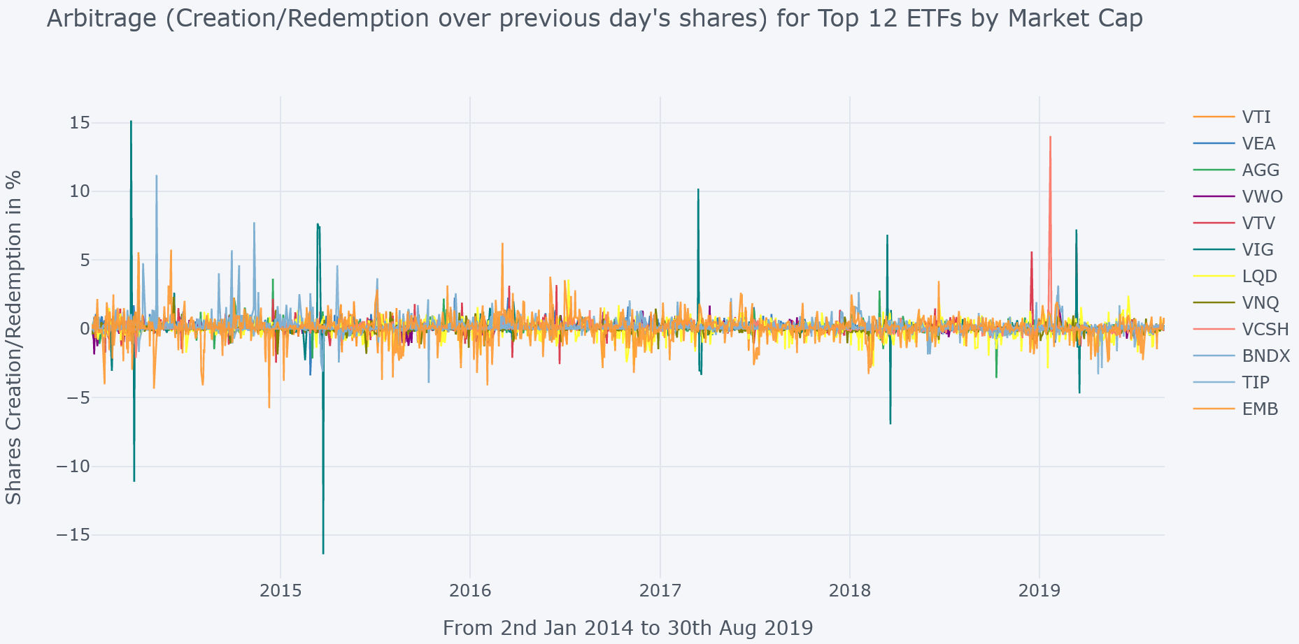
Abs Mean: 0.20%
Std Dev: 0.52%
Positive Mean: 0.29%
Negative Mean: -0.39%
The relation between mispricing and arbitrage is not clear by viewing the plots above or assessing the summary statistics. Thus, a scatter plot is utilized to gauge mispricing impact as seen in Figure 9. Since mispricing follows arbitrage [2], the horizontal axis represents lagged version of mispricing (as on the previous day), and the vertical axis shows the arbitrage on the present day (the next day). As can be seen, it is mostly concentrated around zero; however, as the mispricing increases on the positive side (P > NAV), the arbitrage usually expands (mostly to represent share creation), which is dominated by EMB and VEA. On the other side, the impact does not appear to be strong. VWO show varied levels of mispricing without apparent impact on arbitrage. The VIG and VTV show few unpredictably high arbitrages while mispricing is close to zero. The overall view does show some relation; however, it is not strong because this type of arbitrage by APs is not necessarily facilitated at the end of the day after the price is closed. The NAV is updated every 15 seconds , and resulting arbitrage may happen accordingly. The scatter plot for mispricing and arbitrage on the same day merely changes.

Figure 9: Scatter Plot between Mispricing % and arbitrage next day for Top 12 ETFs by market cap (Jan 2014 to Aug 2019)
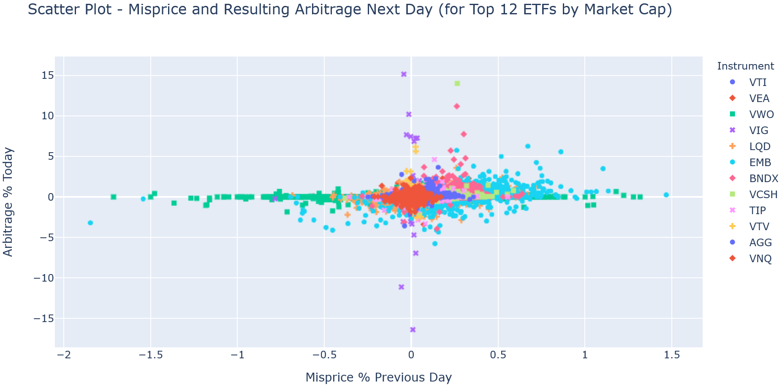

4.3 Low 11 ETFs by Market Cap

Figure 10 shows mispricing for the low 11 ETFs along with summary statistics. To compare it with all ETFs combined, the absolute mean is higher only by 0.02% (0.15% vs 0.13%). The standard deviation is higher by 0.03% (0.25% vs 0.22%). The positive mean is the same; however, the negative mean is -0.16% (against -0.013%). As can be seen, low 11 ETFs show slightly higher mispricing, led by SPEM and SJNK (both issued by State Street Global Advisors). The arbitrage activity for the same ETFs and relevant statistics are presented in Figure 11. It appears to have a higher range of arbitrage in comparison to all ETFs combined, on both positive and negative sides (0.73%/-0.92%) relative to all ETFs combined (Figure 6) and top 12 (Figure 8). The deviation is 0.99% (vs -0.56% for all ETFs).

Figure 10: Mispricing (Closing price minus NAV) for Low 11 ETFs by market cap (Jan 2014 to Aug 2019)
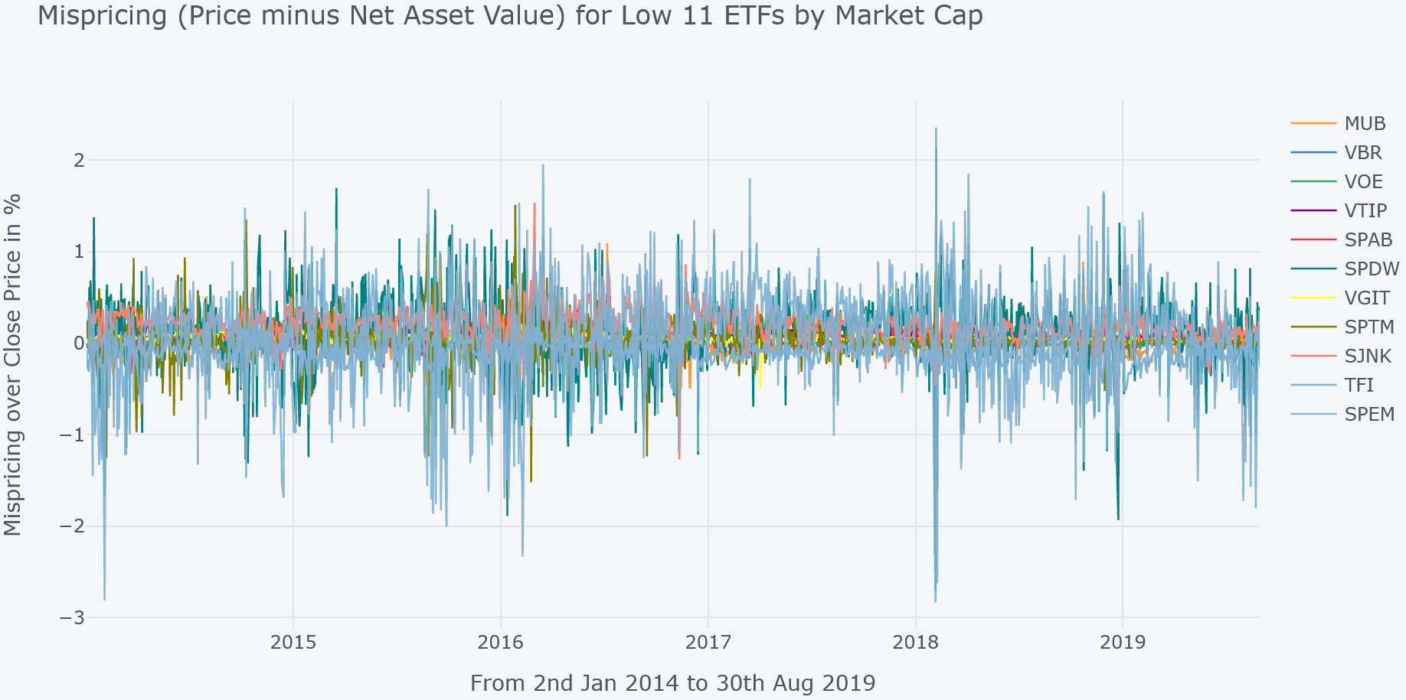
Abs Mean: 0.15%
Std Dev: 0.25%
Pos (P > NAV) Mean: 0.15%
Neg (NAV > P) Mean: -0.16%

Figure 11: Arbitrage (Shares Creation or Redemption) for Low 11 ETFs by market cap (Jan 2014 to Aug 2019)
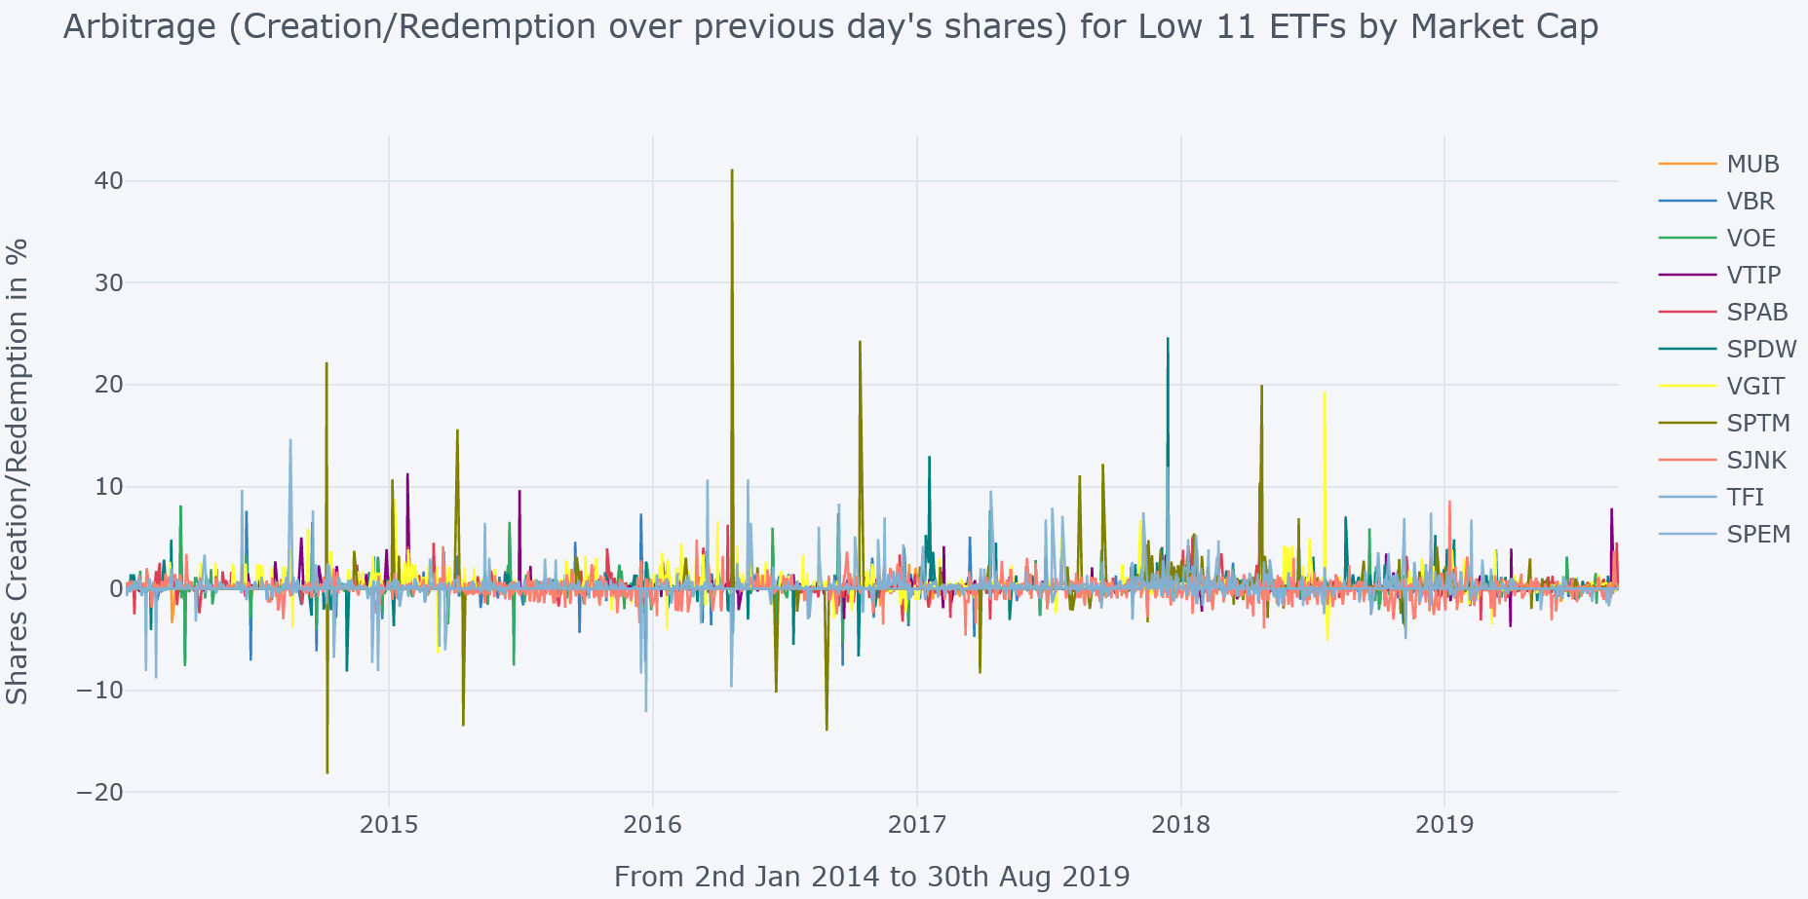
Abs Mean: 0.28%
Std Dev: 0.99
Positive Mean: 0.73%
Negative Mean: -0. 92%

A scatter plot for Low 11 ETFs can be seen in Figure 12. Similar to the top 12, it is mostly concentrated around zero, and the arbitrage usually expands on positive (shares creation) as the mispricing increases (P > NAV), which SPEM and SPDW dominate. They also react to mispricing on the other side too.

Figure 12: Arbitrage (Shares Creation or Redemption) for Low 11 ETFs by market cap (Jan 2014 to Aug 2019)
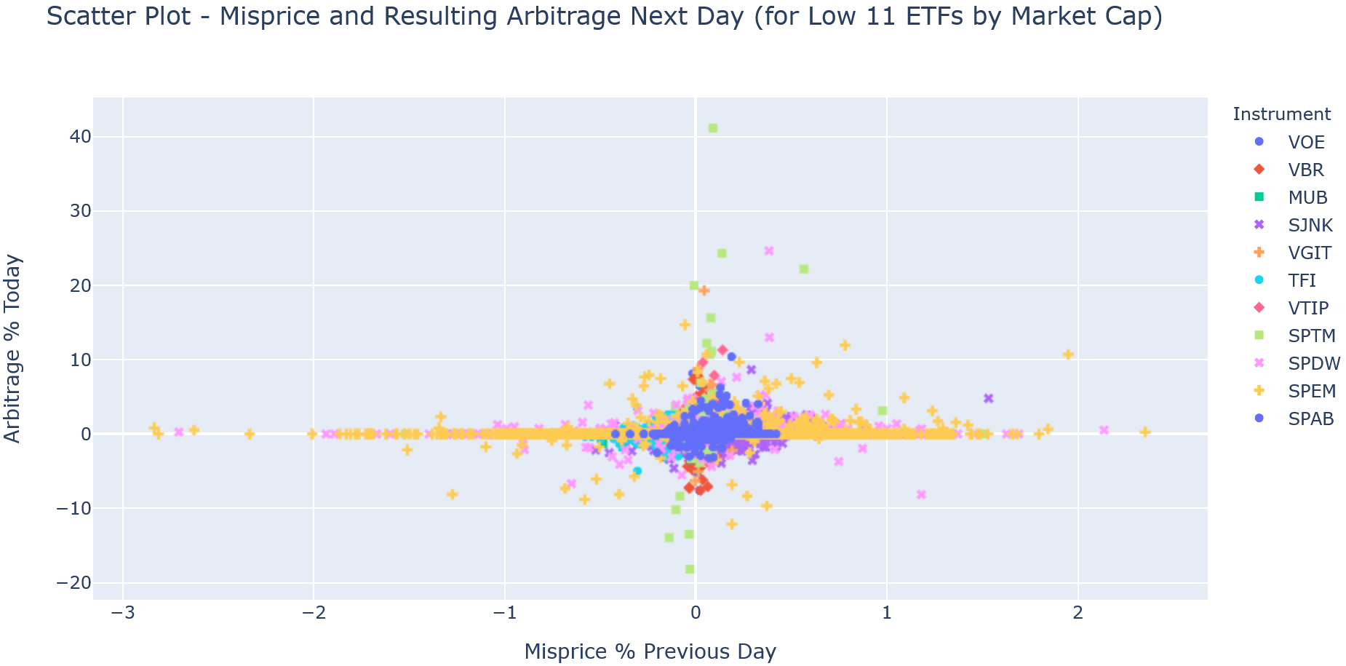

4.5 Individual ETFs and Robo-Advisors

Table 4 provides some stats of individual ETFs for both variables (mispricing and arbitrage), sorted by their absolute means in descending order. The absolute mean accounts for each day (including 0) and considers both positive and negative changes equally to produce an actual daily average. As can be seen SPEM, SPDW, and VWO contribute most to the higher mispricing as per the absolute mean. They also show the highest variations. The top 3 (EMB, SJNK, and LQD) for arbitrage are not represented by the same ETFs, which is very much possible due to the reason outlined in subsection 4.2. The highest variability is further shown by different ETFs, i.e., SPTM, SPEM, and SPDW.

Table 4: Mispricing and Arbitrage Stats of individual ETFs (Jan 2014 – Aug 2019)
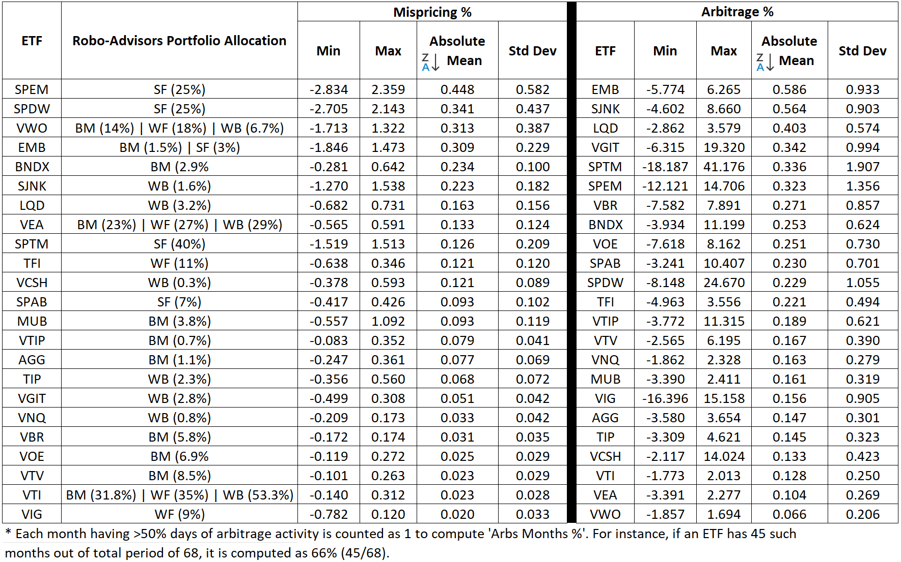

A portfolio time-series is created for both the variables based on daily changing weights ($W$) of constituent ETFs, i.e., $W_{it}$, where $i$ represents an ETF within a portfolio and $t$ is a day. They are computed as below.
$$Robo Portfolio {Mispricing}_{t}=\sum_{i=0}^{n}{W_{it}*{Mispricing}_{it}}$$
$$Robo Portfolio {Arbitrage}_{t}=\sum_{i=0}^{n}{W_{it}*{Arbitrage}_{it}}$$
The statistics is derived from the time-series, which follows a state of each Robo-Advisor as presented in Table 5, whereSigFig shows the highest measures for both variables. The mispricing is led by its constituent ETF SPEM (emerging market stocks) that skews on higher side and represent initial allocation of 25%. Similarly, the arbitrage side is impacted by SPTM (US stocks) that has a 40% initial weight. The plots of both variables (arbitrage and mispricing) for each Robo-advisors can be found in Appendix B and C for visualization and summary statistics.

Table 5: Mispricing and Arbitrage Stats of each Robo-Advisor (Jan 2014 – Aug 2019)
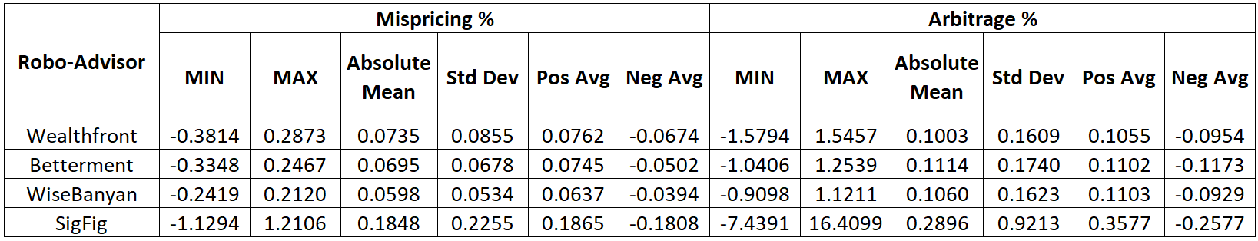

5 Bid/Ask Spread

5.1 Bid/Ask Spread for Top 12 ETFs by Market Cap

The bid/ask spread refers to the difference between the best offer (Ask) at which one is willing to sell and the best buy (bid) at which one is willing to buy. For this section, it is computed as a percentage over the mid-price ($\frac{Best Ask- Best Bid}{Mid Price}$). After a closer look, a few outliers beyond 1% are considered data anomalies and excluded. It is a key element of a limit order book for any financial instrument. Usually, highly liquid markets have tight (low) spreads and illiquid markets experience wider spread. It is found that mispricing is higher for ETFs with a larger spread. They also get wider in a distressed market when arbitrageurs find it difficult to arbitrage, which may cause further deviation of ETF price from its fundamental value. [2]

A plotting chart representing the spread for the top 12 ETFs by market cap is shown in Figure 13. It appears much higher to start with, which decreases with time. A deep dive suggests that most of the ETFs remain within 0.1% throughout except BNDX and EMB. The BNDX’s inception date was 31st May 2013, which was relatively new in our study's beginning period. It is believed that spreads are likely to be relatively higher for ETFs when launched, which comes down as the market gets more familiar and competition increases [2]. The overall average of these 12 ETFs comes down to 0.019% for the full period in question. The Equity ETFs have an average and median spread of 0.41% and 0.21%, respectively. Thus, ETFs for our analysis seem to have quite a tight spread.

Figure 13: Bid/Ask Spread % for Top 12 ETFs by market cap (Jan 2014 to Aug 2019)
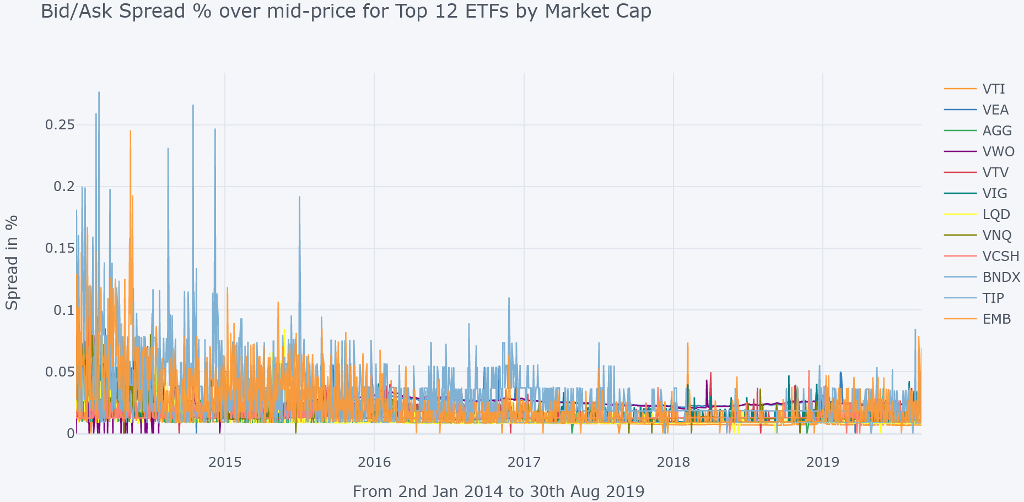
Average: 0.019%

5.2 Bid/Ask Spread for Low 11 ETFs by Market Cap

Figure 14 covers the spread for Low 11 ETFs. Its overall average is 0.067%, which is much higher than the top 12 ETFs, though within an acceptable limit. It also displays a much higher spread at the start of the period. Upon further analysis, it is found that SPTM, SPDW and SPEM mainly contribute to it, which are all managed by State Street Global Advisors. While higher than top 12, it may still be deemed tight relative to industry standards, as highlighted under the previous subsection.

Figure 14: Bid/Ask Spread % for Low 11 ETFs by market cap (Jan 2014 to Aug 2019)
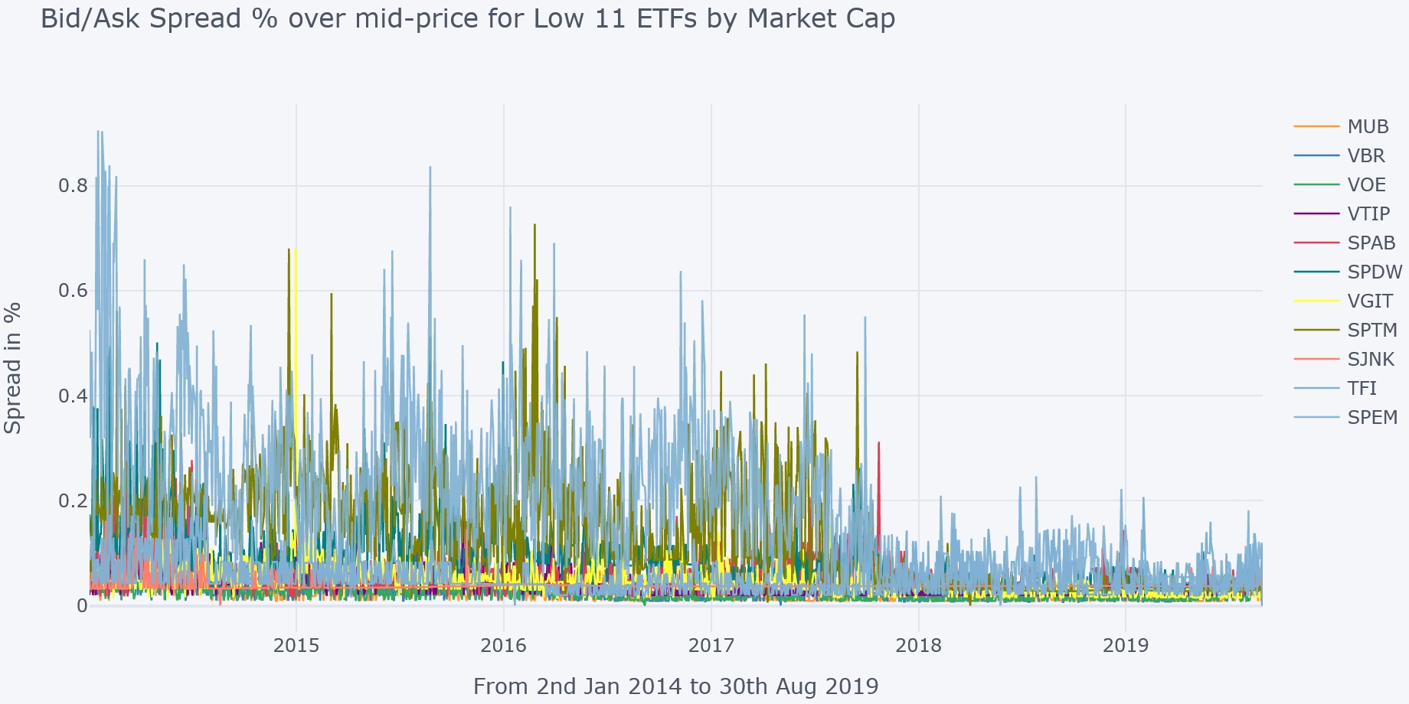
Average: 0.067%

5.3 Bid/Ask Spread and ETF Price Return

Although the mean for 12 ETFs in question is well under an average spread of equity ETFs in the market, the impact of spikes is not visible. A scatter plot in Figure 15 depicts ETF price returns movement along different bid/ask spread levels. It helps to gauge if a higher spread leads to prices in a specific direction and resulting pattern. As can be seen, price returns are almost equally distributed around the higher spread range; thus, it is difficult to conclude.

Figure 15: Bid/Ask Spread and ETF Price Returns for all 23 ETFs (Jan 2014 to Aug 2019)
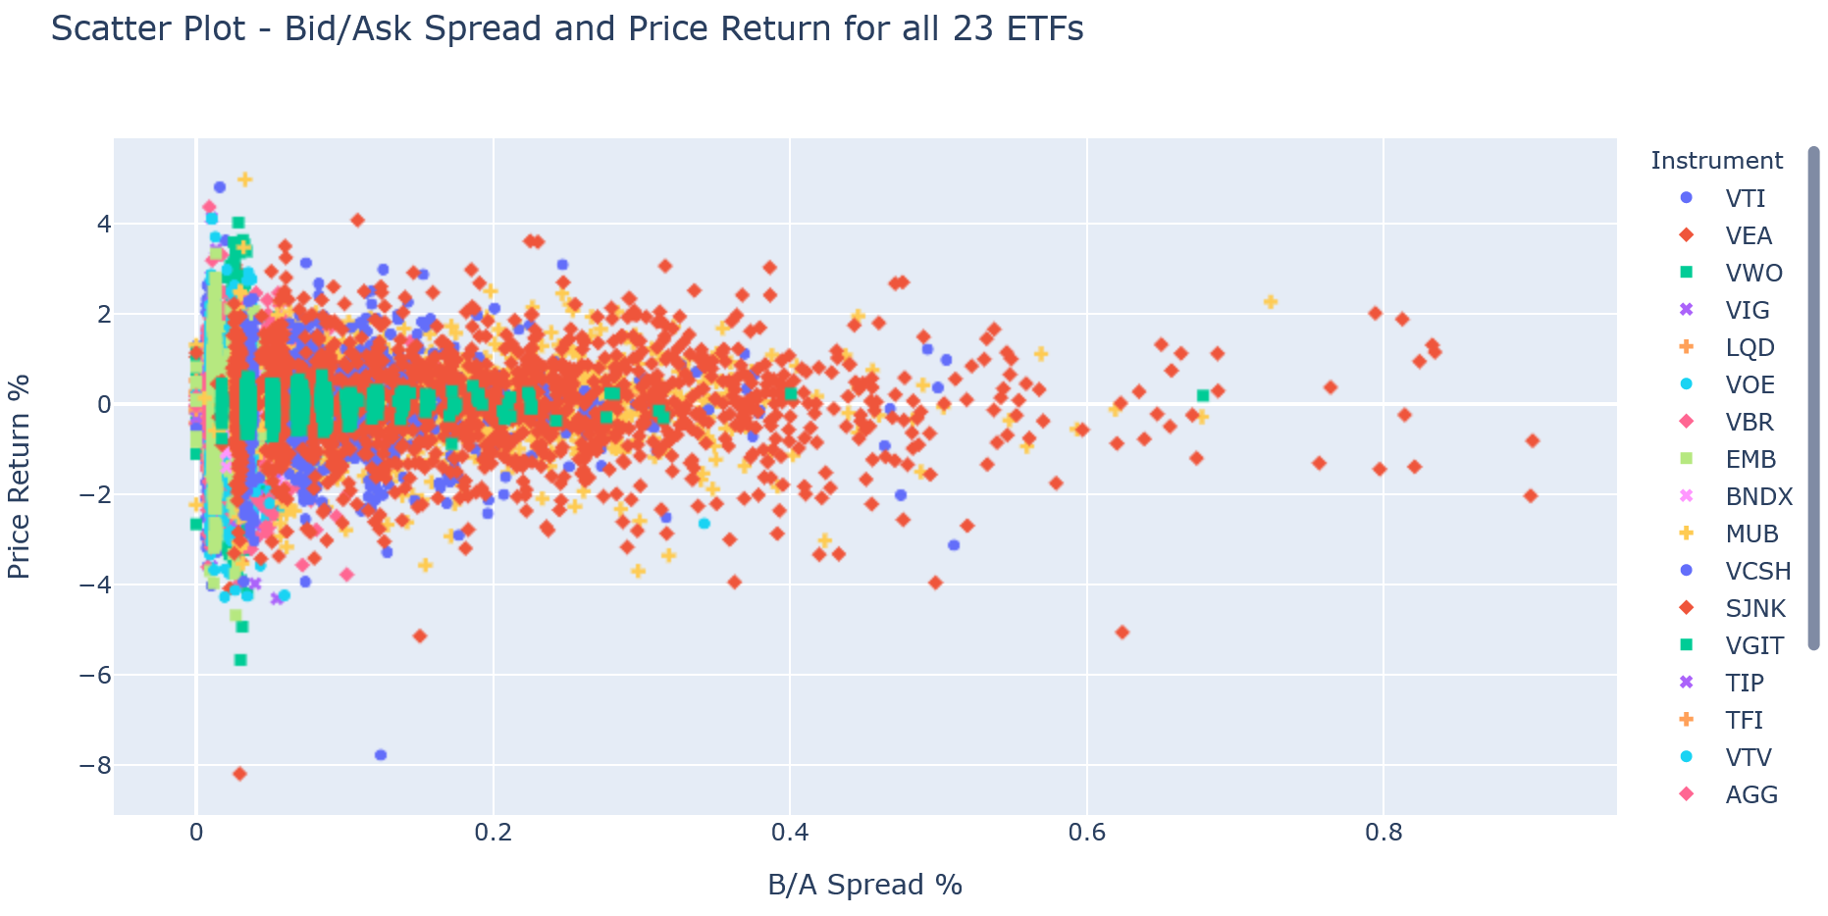

6 Short Interest

6.1 Short Interest for Top 12 ETFs by Market Cap

Short Interest refers to the number of shares that are sold short and remain outstanding. This is achieved by traders borrowing a financial instrument to sell at a market price to buy back later and return with a bearish mindset. It is often presented as a percentage over outstanding shares, which will be used for analysis in this section. Few outliers outside 25% are excluded. An increase in short interest may be perceived as bearish sentiment. [3]

It is presented as a time-series plot for the Top 12 ETFs by market cap in Figure 16. It appears to be random, as different ETFs can be seen all over the place. EMB starts much higher at about 20% short interest relative to others and comes down over a period. LQD starts within the range of 5% but shorting moves up towards the end. Most others remain well below 5% of outstanding shares most of the time. The overall average across 12 ETFs is 1.93%. No correlation is found with a market cap or any other variable.

Figure 16: Short Interest for Top 12 ETFs by market cap (Jan 2014 to Aug 2019)
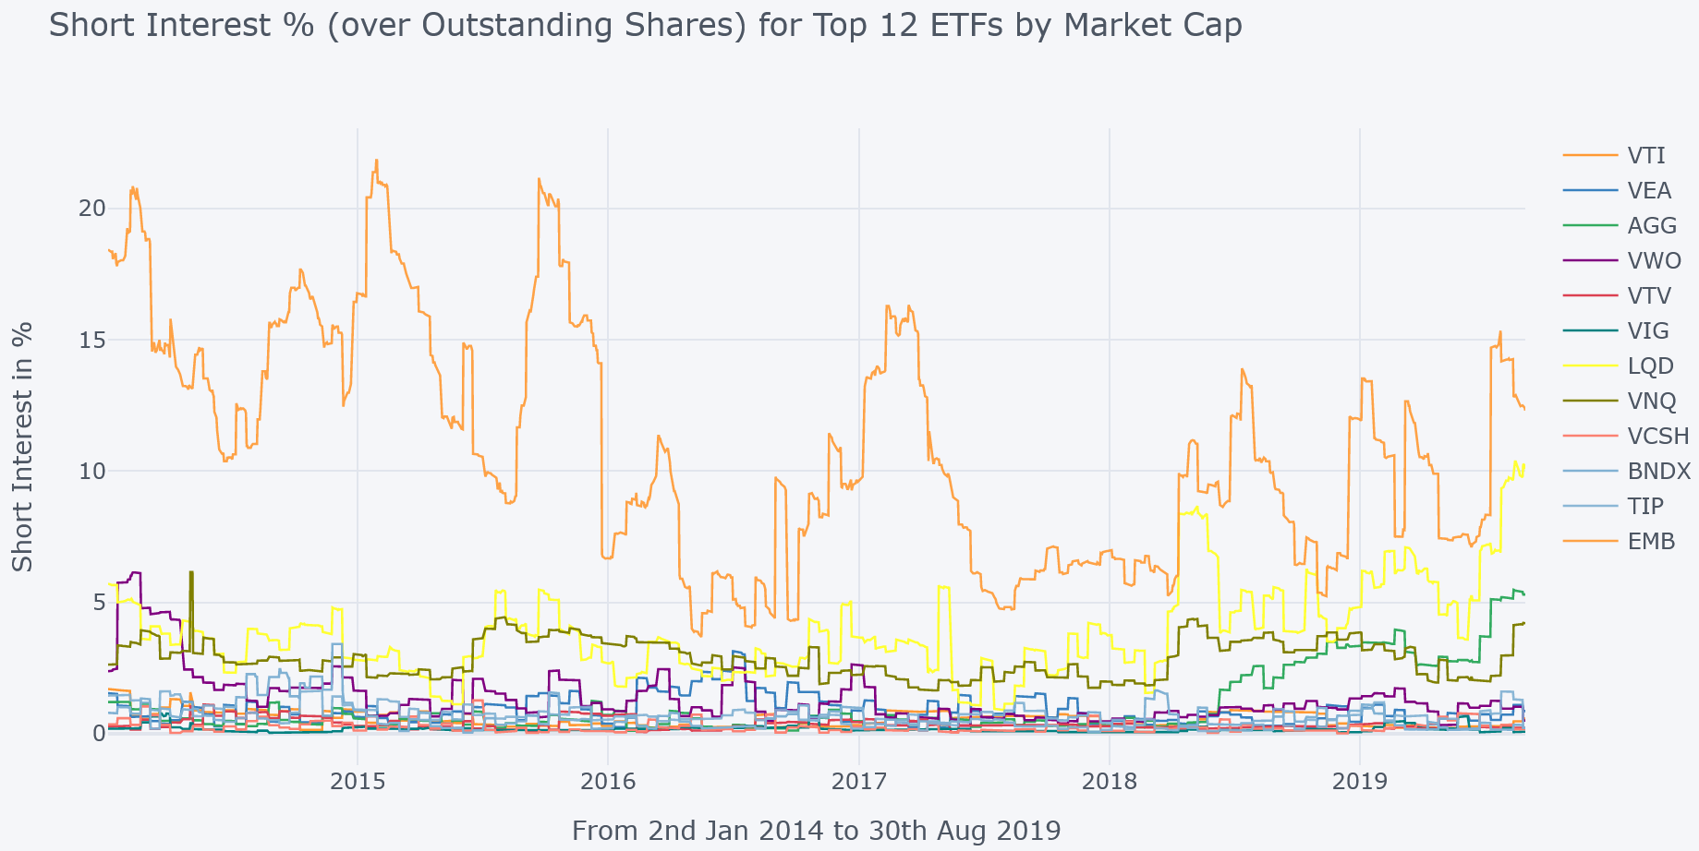
Average: 1.93%

6.2 Short Interest for Low 11 ETFs by Market Cap

Figure 17 presents it for low 11 ETFs by market cap. SPTM and SPEM have few spikes in the short interest. Rest remains well under 5%. Although the overall average is 0.71%, much lower than top 12 ETFs, the result is skewed due to EMB having much higher short interest at any given time. It can also be seen from the perspective of Robo-advisors in Table 6 above, along with stats for bid/ask spread. SigFig has the highest short interest mean of 2.91%, followed by Betterment at 1.57%. The standard deviation of both is also highest in the same order. The plot of each advisor can be found in Appendix D.

Figure 17: Short Interest for Low 11 ETFs by market cap (Jan 2014 to Aug 2019)
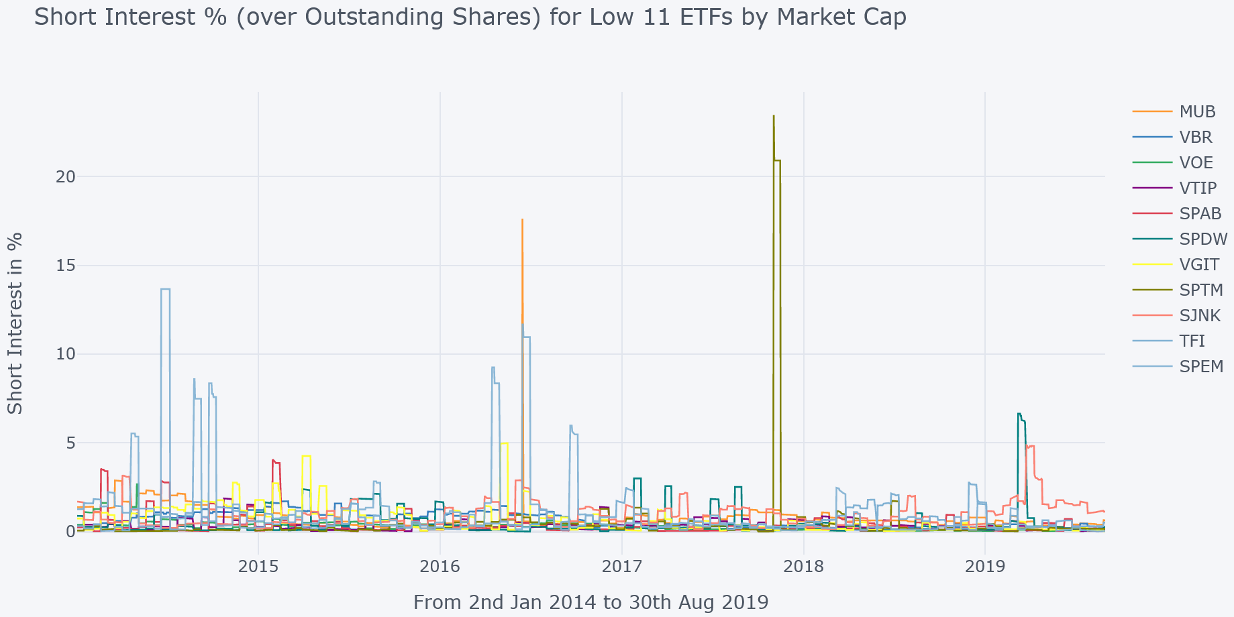
Average: 0.71%

6.3 Short Interest and ETF Price Return

A high short interest (which may vary for different asset classes/sectors) usually puts pressure on price, making it go downward. A scatter plot in Figure 18 shows ETF price returns along different levels of Short Interest to assess if higher short interest leads to a certain pattern. As can be seen, price returns do not behave much differently (or skew on either side) around the higher range of Short Interest; thus, no conclusion about its impact can be made.

Figure 18: Short Interest and ETF Price Returns for all 23 ETFs (Jan 2014 to Aug 2019)
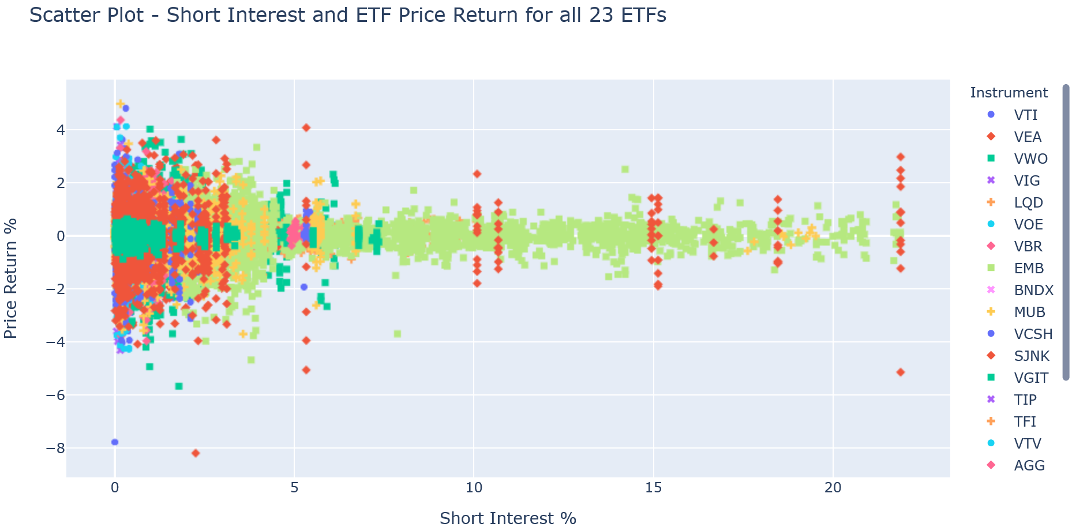

6.4 Individual ETFs and Robo-Advisors (Bid/Ask Spread and Short Interest)

Some of the stats for each ETF can be found in Table 6 below, on Bid/Ask Spread along with Short Interest, sorted in descending order by their respective means. As can be seen SPEM, SPTM, and SPDW contribute most to the higher spread. They also show the highest standard deviation. The top 3 for Short Interest are EMB, LQD, and VNQ where EMB is relatively significantly higher as also observed in Figure 16. The highest variability is not observed by same set of ETFs, as SPEM and SPTM show higher standard deviation.

Table 6: Bid/Ask Spread and Short Interest for each ETF (Jan 2014 – Aug 2019). Top 3 in bold.
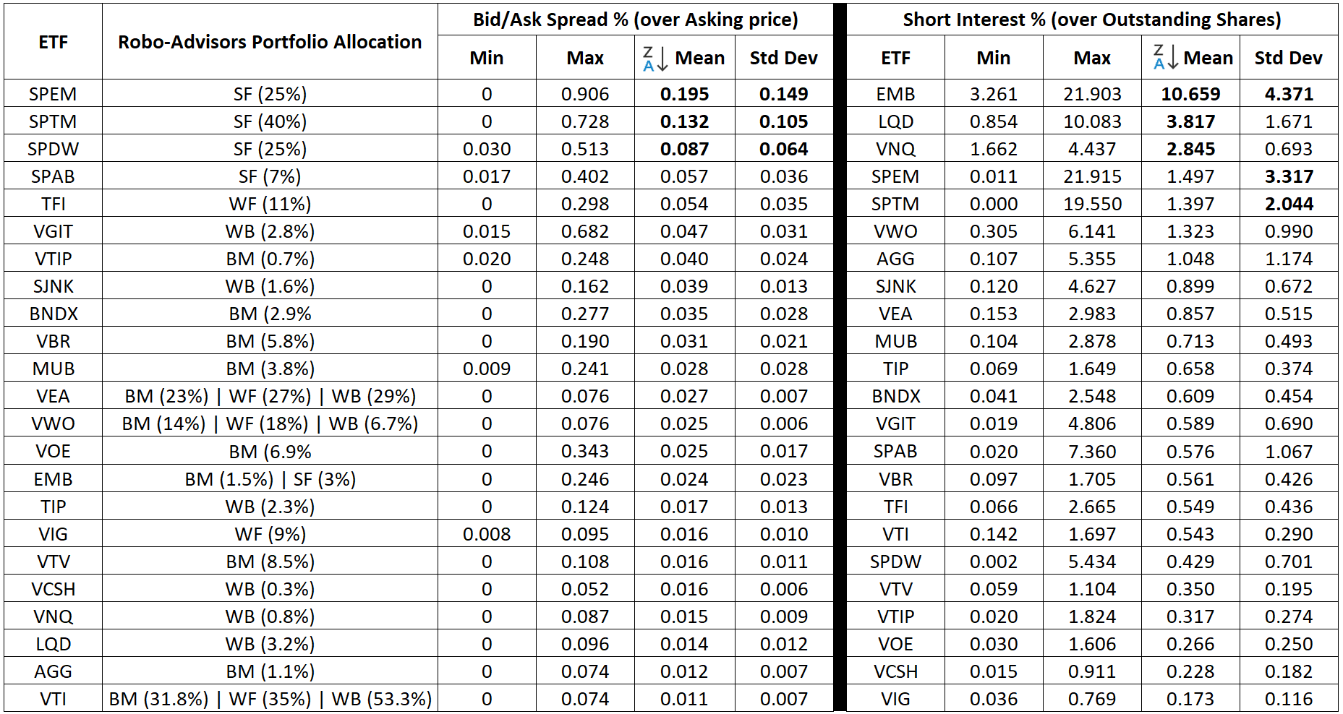

Table XX: Daily Amihud Illiquidity Measure for $1M trading volume (Jan’19 – Aug’19)
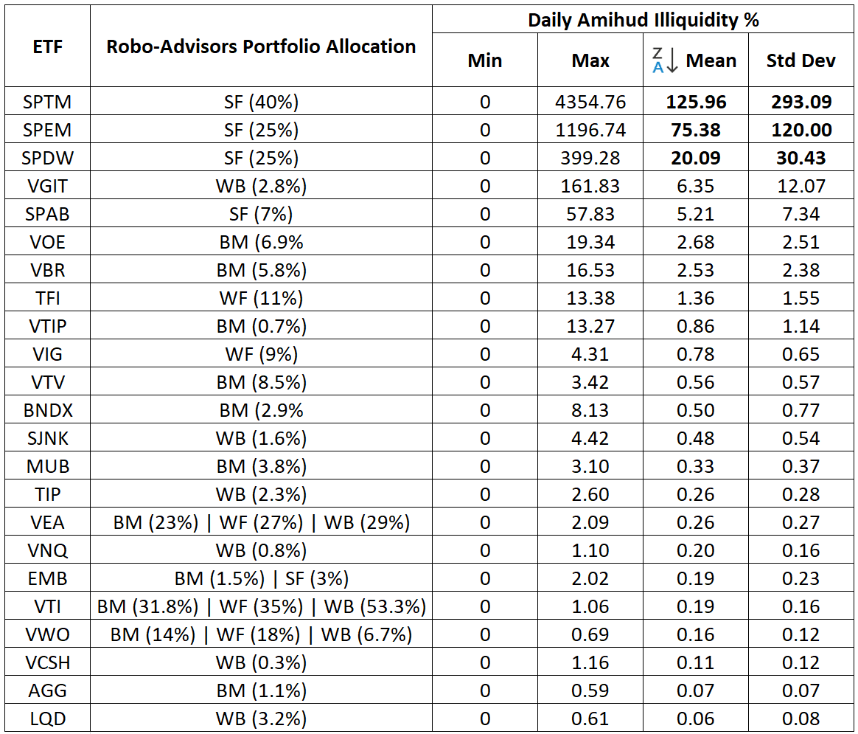
The mean and Std Dev of each Robo-advisor are presented in Table 7 after assigning relevant weights. SigFig has a relatively significantly higher mean and standard deviation in comparison to others, led by SPTM and EMB as can be noticed in combined statistics for individual ETFs in Table 6. It is worth highlighting that most of its constituent ETFs are managed by State Street Global Advisors (4 out of 5). Its variability is also relatively much higher. The plots for each Robo-advisors' spread can be found in Appendix D for visualization.

Table 7: Bid/Ask Spread and Short Interest for each Robo-Advisor (Jan 2014 – Aug 2019)
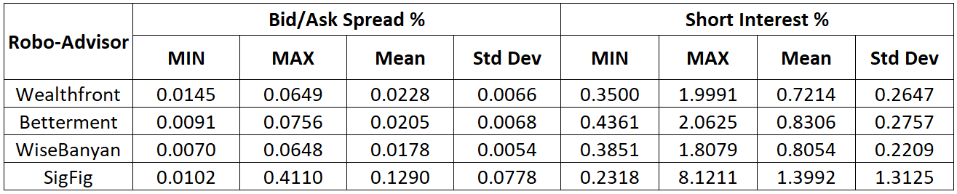

Table XX: Stats on Daily Amihud Illiquidity Measure (Jan 2014 – Aug 2019)
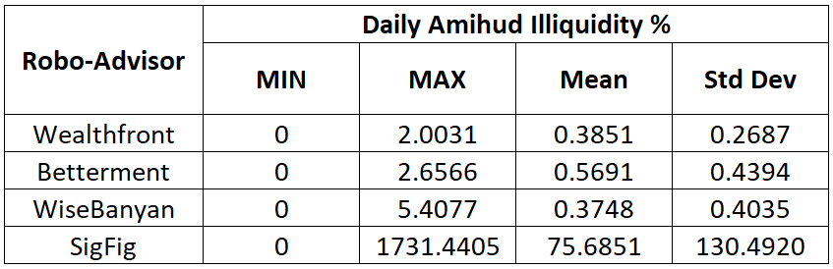

7 Rebalancing

All 4 Robo-advisors aim to maintain a close range of initial portfolio allocation to all constituent ETFs. The initial target allocation deviates from the rise and fall in the value of ETFs disproportionally. For instance, at some stage, 12% initial allocation to VTI may change to 9% or 15% of the total portfolio value. At such times, the portfolio is rebalanced, during which Robo-Advisors buy/sell constituents' ETFs to bring back the weights of each ETF to initial (target) allocation. The rebalancing is assumed to be done at the end of each month. The ETF weightage is categorized as either significant (>10%) or small allocation (<=10%), as assumed in the absence of precise classification followed by each Robo-Advisors. The rebalancing only gets triggered when the minimum absolute deviation for any small allocation reaches 2.5% (or 5% for larger allocation). Tracking each of 4 Robo-Advisors’ portfolio values each month (starting with a $10,000 allocation), Wealthfront needed to rebalance 3 times between Jan 2014 and Aug 2019. Betterment and SigFig rebalanced only once during the same period. WiseBanyan rebalanced twice.

References:
[1] David Brown, Shaun Davies, Matthew Ringgenberg. ‘ETH Arbitrage and Returns Predictability’, 2016
[2] I. Ben-David, F. A. Franzoni, and R. Moussawi, ‘ETFs, Arbitrage, and Contagion’, SSRN Electronic Journal, 2011, Accessed: Sep. 03, 2022. [Online]. Available: https://www.academia.edu/40009694/ETFs_Arbitrage_and_Contagion
[3] ‘BNDX-Vanguard Total International Bond ETF | Vanguard’. https://investor.vanguard.com/investment-products/etfs/profile/bndx (accessed Sep. 03, 2022).
[4] ‘What Is Short Interest?’, Investopedia. https://www.investopedia.com/terms/s/shortinterest.asp (accessed Sep. 03, 2022).

Appendices:

Appendix A: Descriptive Statistics

The table A below shows summary statistics for each ETF (Jan 2014 to Aug 2019). The ones in orange are highest 3 and blue ones are lowest 3 of all. It provides a quick glance over range (min & max), mean, median, std dev and other statistics of the market cap of each ETF.

Table A: Descriptive Statistics of ETF’s market cap (Jan 2014 to Aug 2019) | Orange - highest | Blue - lowest

As can be seen, the minimum market cap of lowest 3 ETFs i.e., SPEM, SPTM and VGIT during this period is just under $250M. And among top 3 i.e., VEA, VTI and VWO under minimum value, it starts at $18.5B. All the ETFs reach close to approx. $3B at some stage. It is also worth noting that kurtosis value of all ETFs is well under 3 (and mostly negative) that implies that distribution of market cap during the said period has thin tails. In other words, the distribution does not have extreme values on either side.

Appendix B: Arbitrage plots for each Robo-Advisor

Wealthfront

Figure B-1: Arbitrage (Shares Creation or Redemption) for Wealthfront
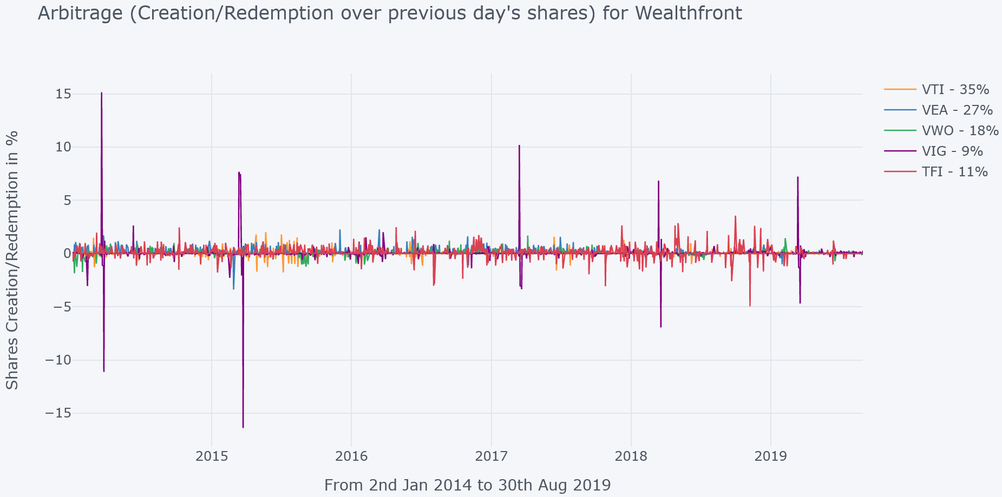
Abs Mean: 0.14%
Std Dev: 0.5
Positive Mean: 0.27%
Negative Mean: -0.36%

Betterment

Figure B-2: Arbitrage (Shares Creation or Redemption) for Betterment
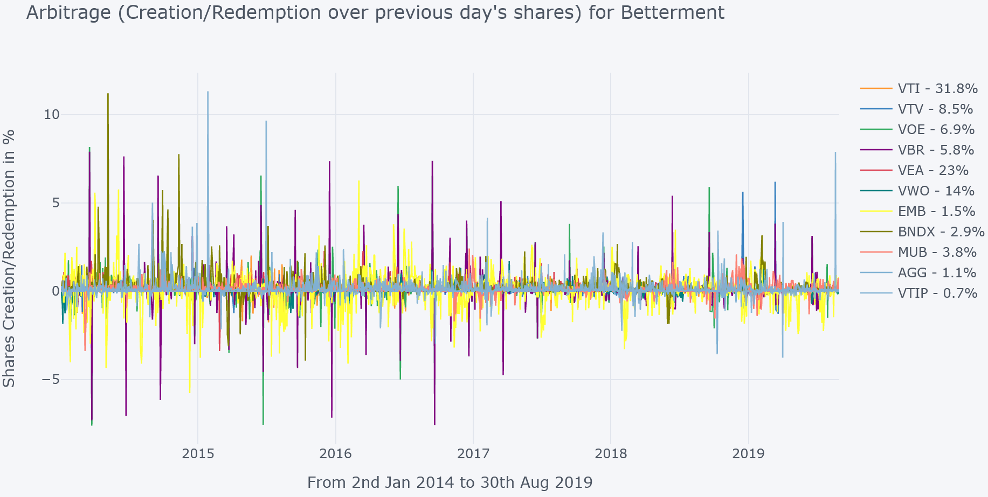
Abs Mean: 0.21%
Std Dev: 0.56
Positive Mean: 0.34%
Negative Mean: -0.51%

WiseBanyan

Figure B-3: Arbitrage (Shares Creation or Redemption) for WiseBanyan
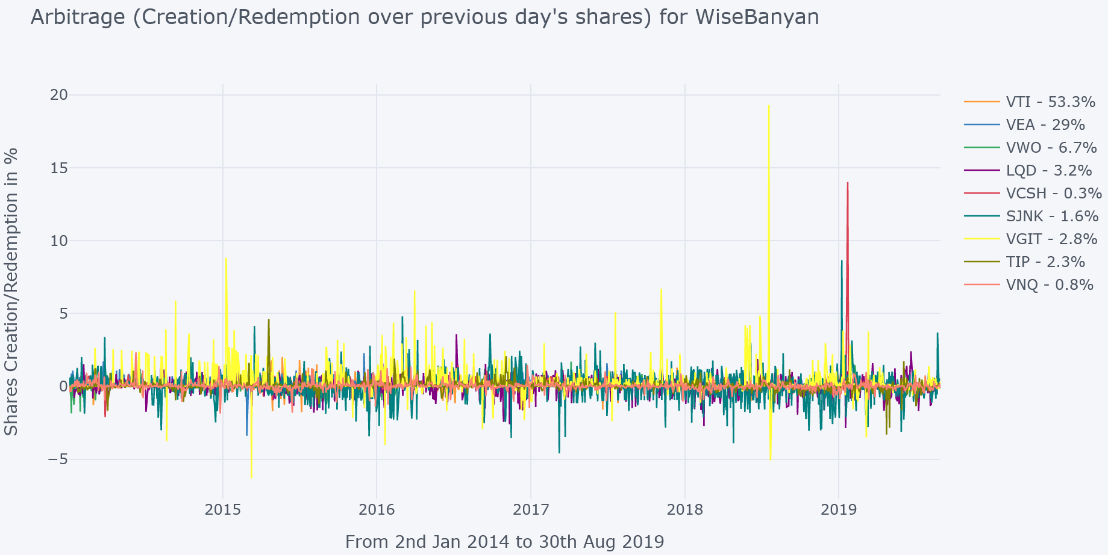
Abs Mean: 0.23%
Std Dev: 0.55
Positive Mean: 0.38%
Negative Mean: -0.44%

SigFig

Figure B-4: Arbitrage (Shares Creation or Redemption) for SigFig
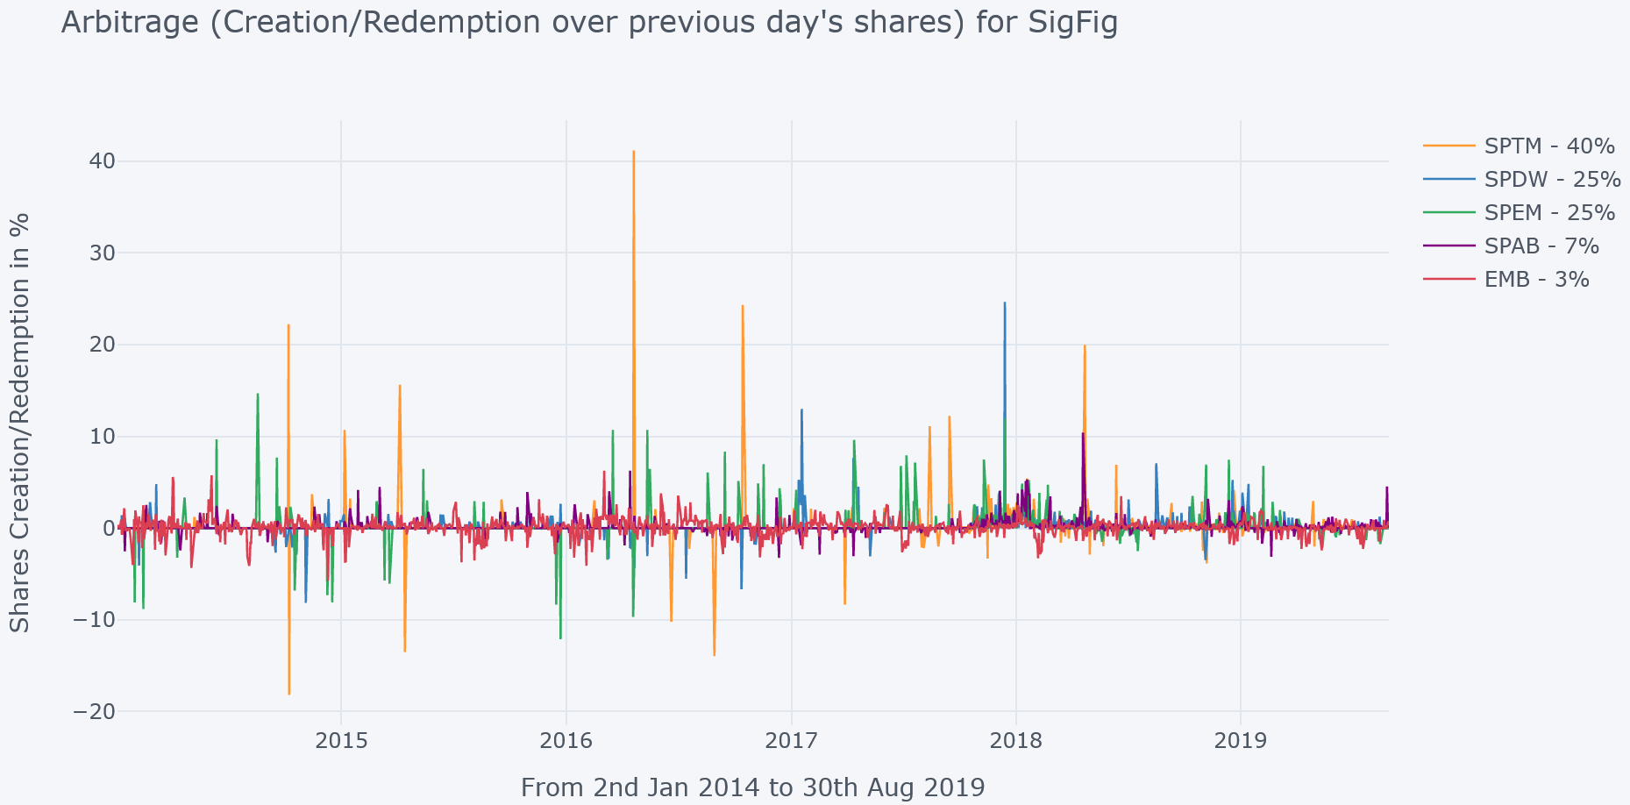
Abs Mean: 0.34%
Std Dev: 1.26
Positive Mean: 1.08%
Negative Mean: -1.24%

Appendix C: Mispricing (Price minus Net Asset Value) plots for each Robo-Advisor

Wealthfront

Figure C-1: Mispricing % (over ETF Price) for Wealthfront

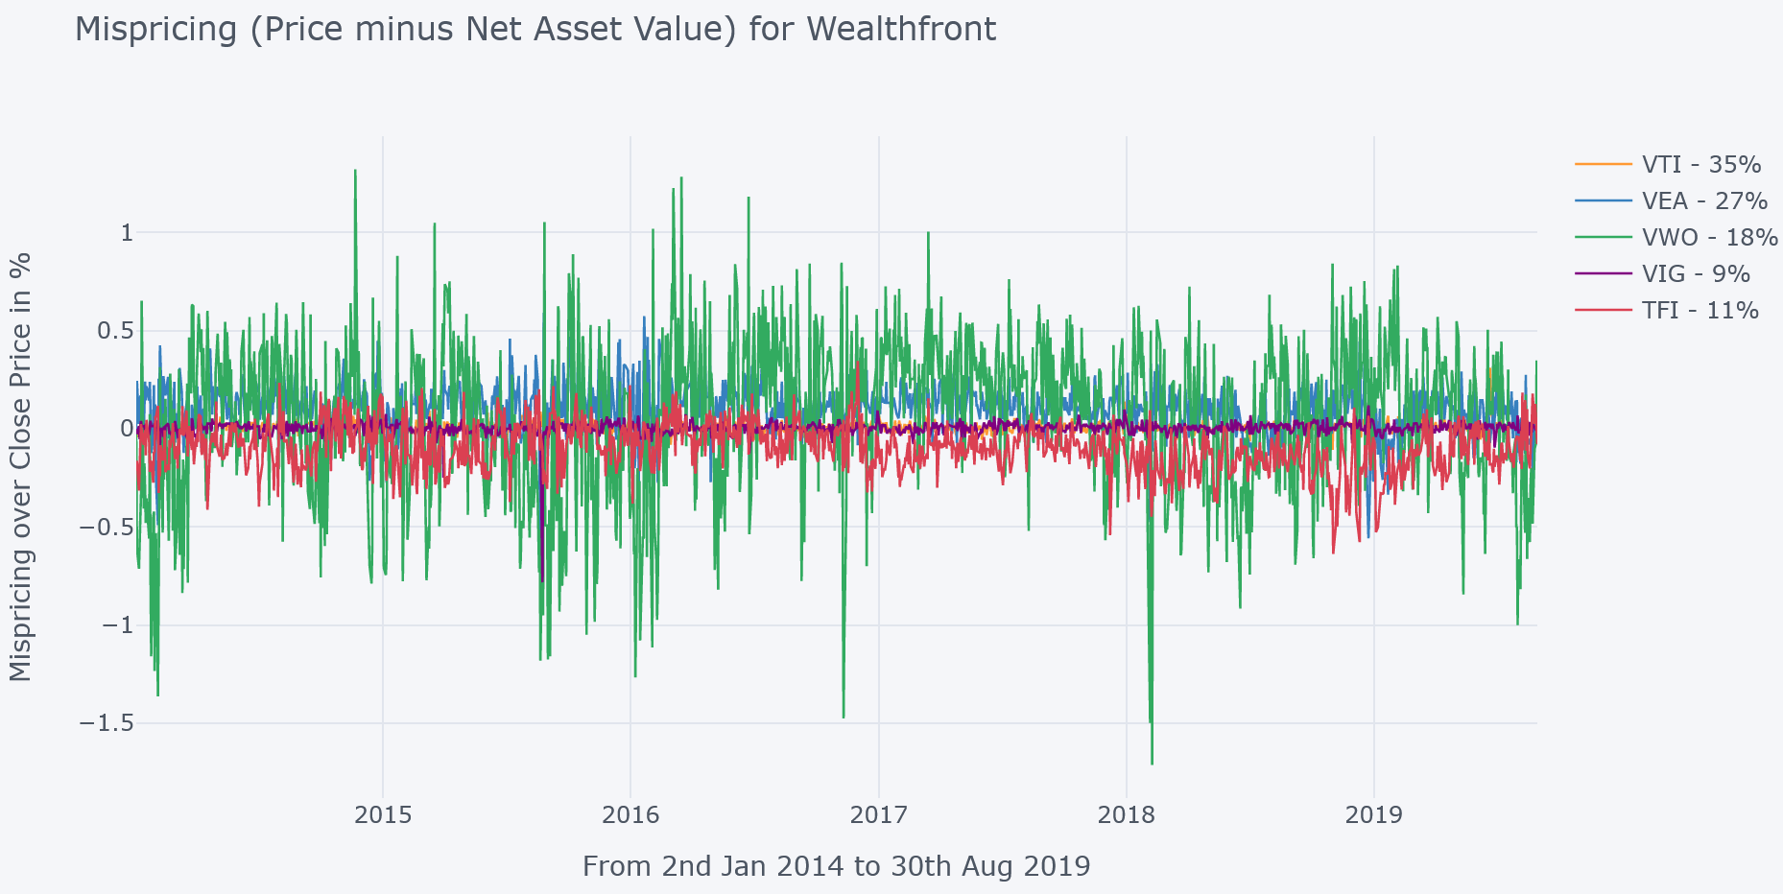
Abs Mean: 0.12%
Std Dev: 0.20
Positive Mean: 0.13%
Negative Mean: -0.14%
Betterment

Figure C-2: Mispricing % (over ETF Price) for Betterment

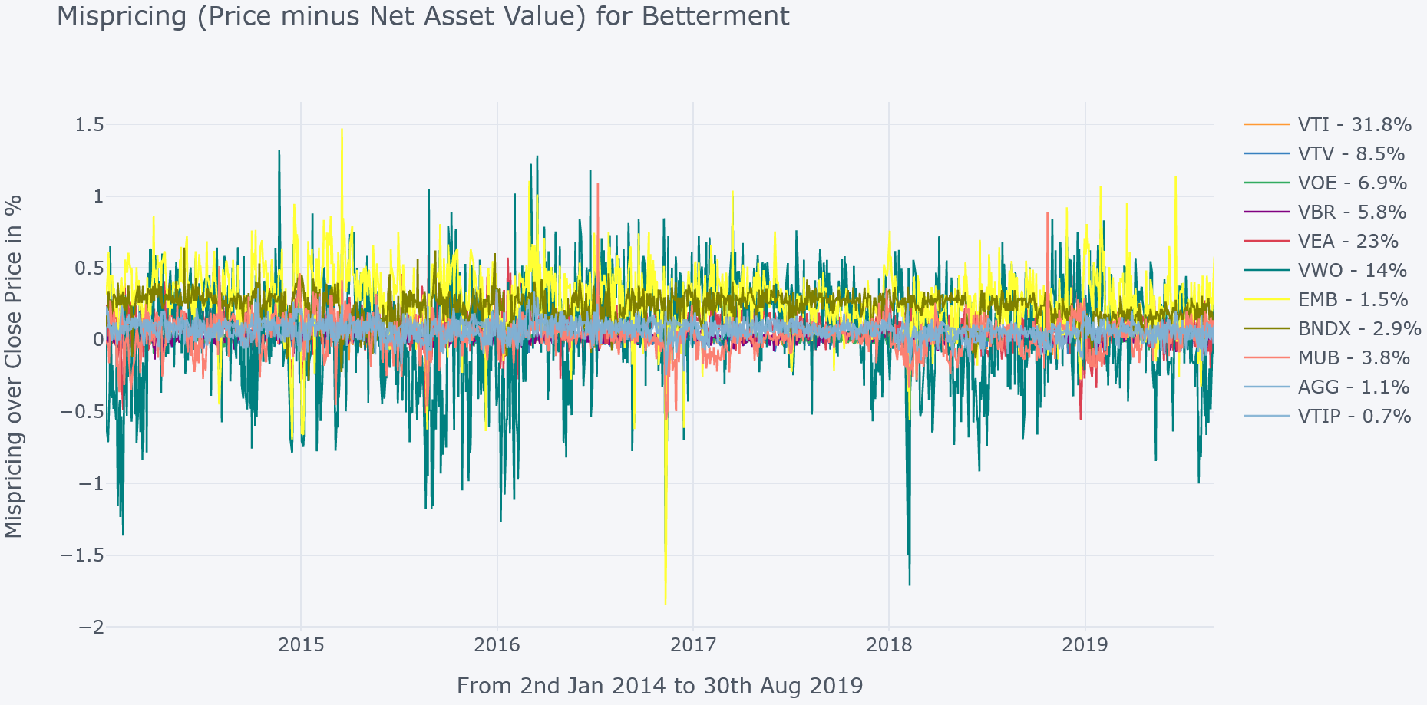
Abs Mean: 0.12%
Std Dev: 0.18
Positive Mean: 0.14%
Negative Mean: -0.1%

WiseBanyan

Figure C-3: Mispricing % (over ETF Price) for WestBanyan
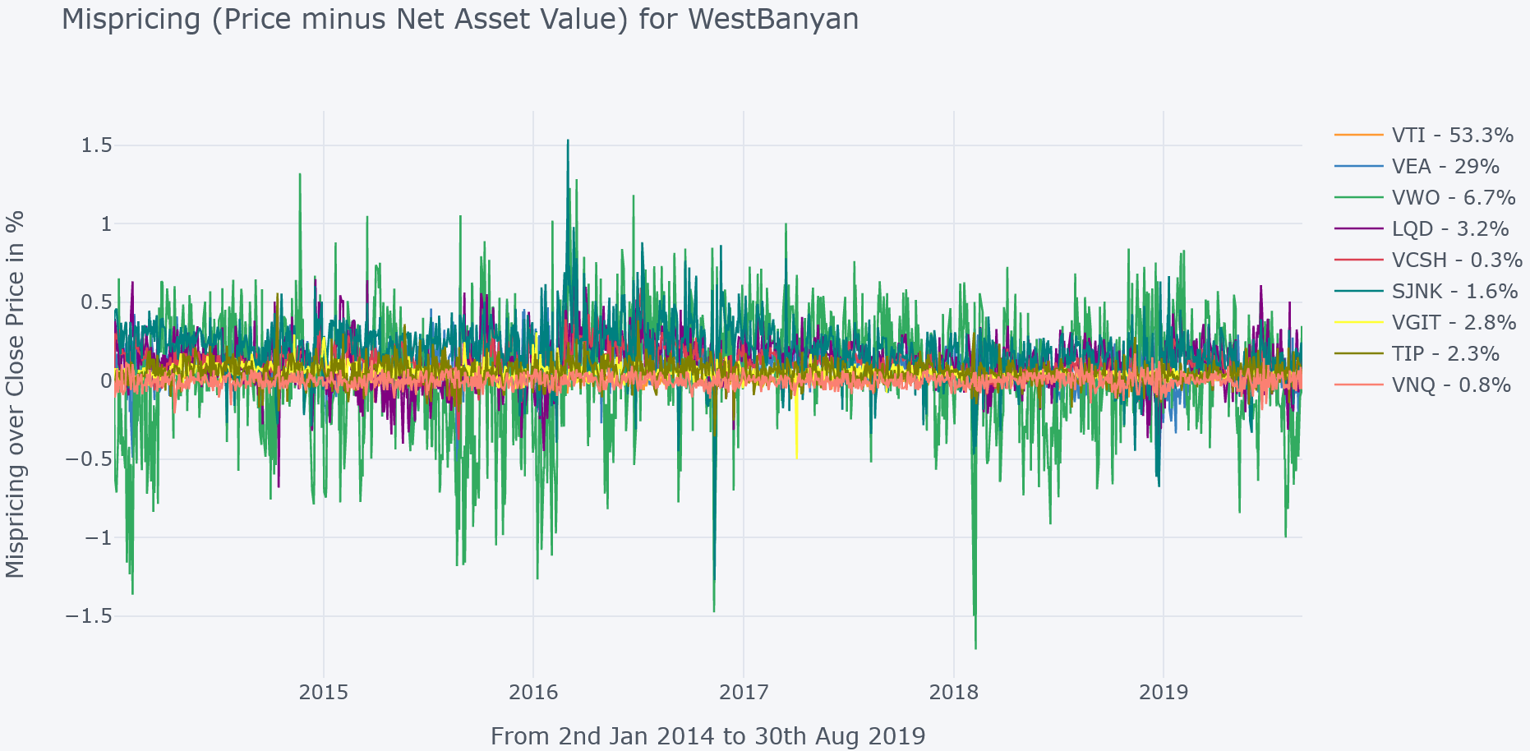
Abs Mean: 0.13%
Std Dev: 0.17
Positive Mean: 0.14%
Negative Mean: -0.11%

SigFig

Figure C-4: Mispricing % (over ETF Price) for SigFig
Abs Mean: 0.26%
Std Dev: 0.37
Positive Mean: 0.26%
Negative Mean: -0.26%
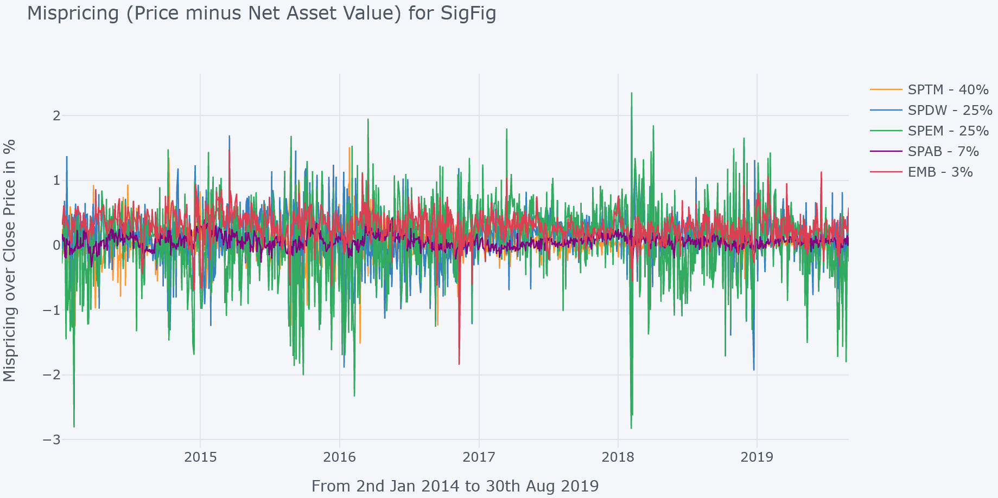

Appendix D: Bid/Ask Spread plots for each Robo-Advisor

Wealthfront
Figure D-1: Bid/Ask Speead % for Wealthfront
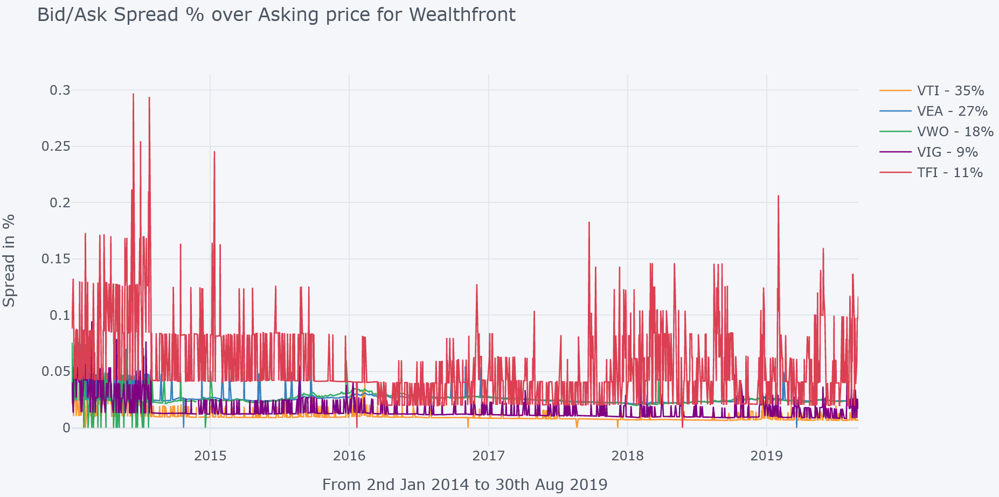
Average: 0.027%

Betterment

Figure D-2: Bid/Ask Spread % for Betterment
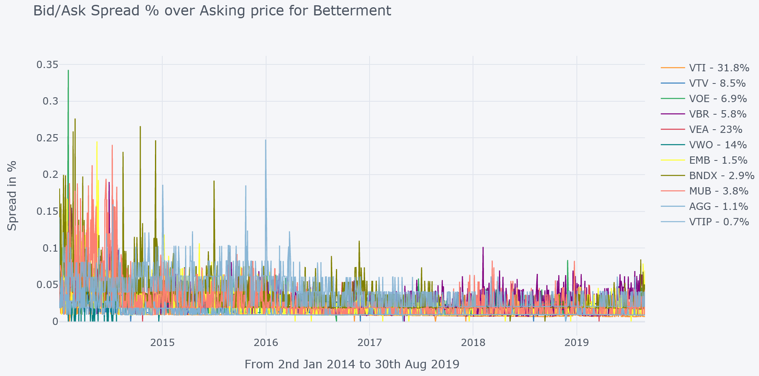
Average: 0.025%

WiseBanyan
Average: 0.024%
Figure D-3: Bid/Ask Spread % for WestBanyan
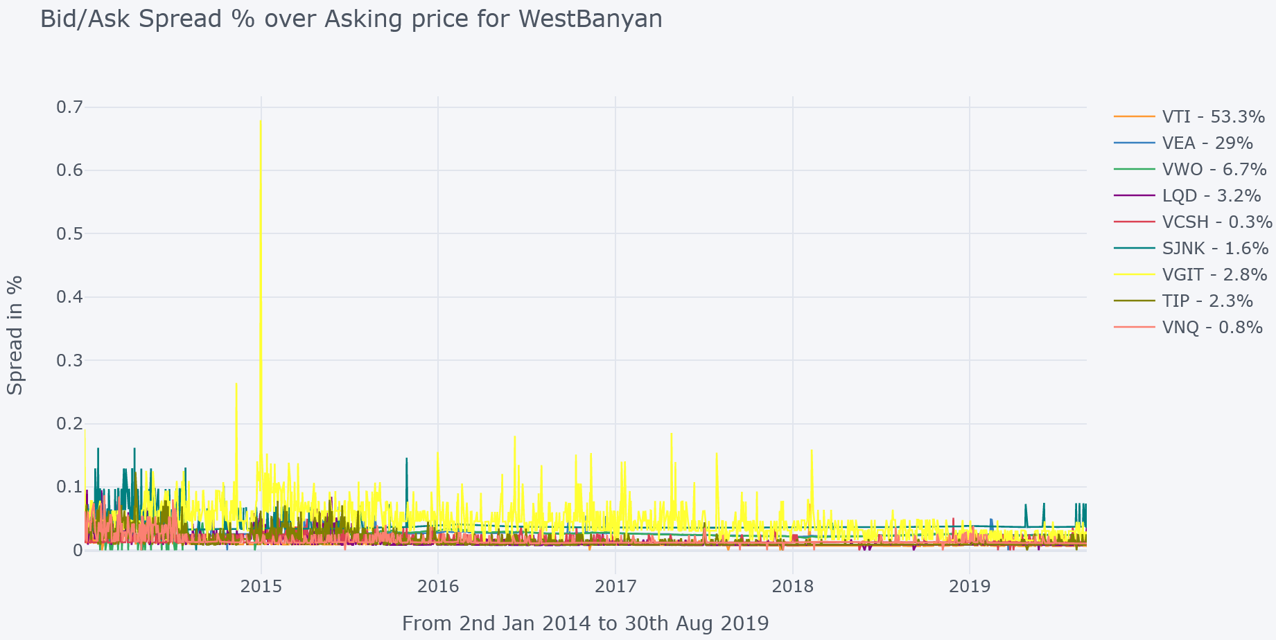

SigFig

Figure D-4: Bid/Ask Spread % for SigFig
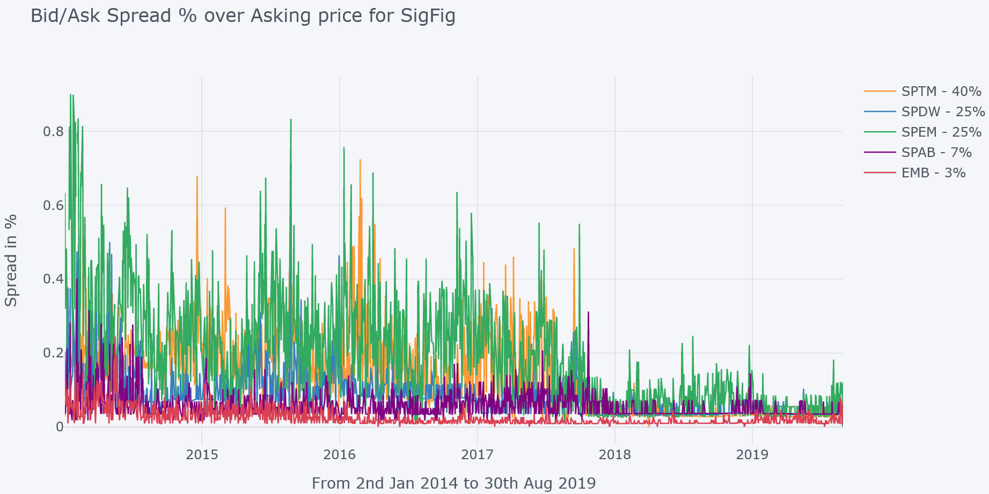
Average: 0.099%

Appendix E: Short Interest % plots for each Robo-Advisor

Wealthfront

Figure E-1: Short Interest for Wealthfront
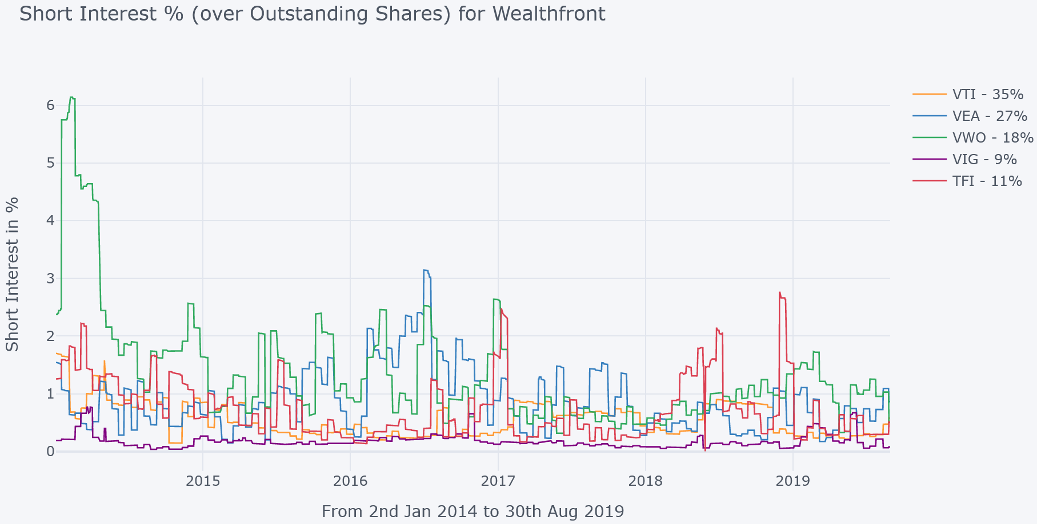
Average: 0.73%

Betterment

Figure E-2: Short Interest for Betterment
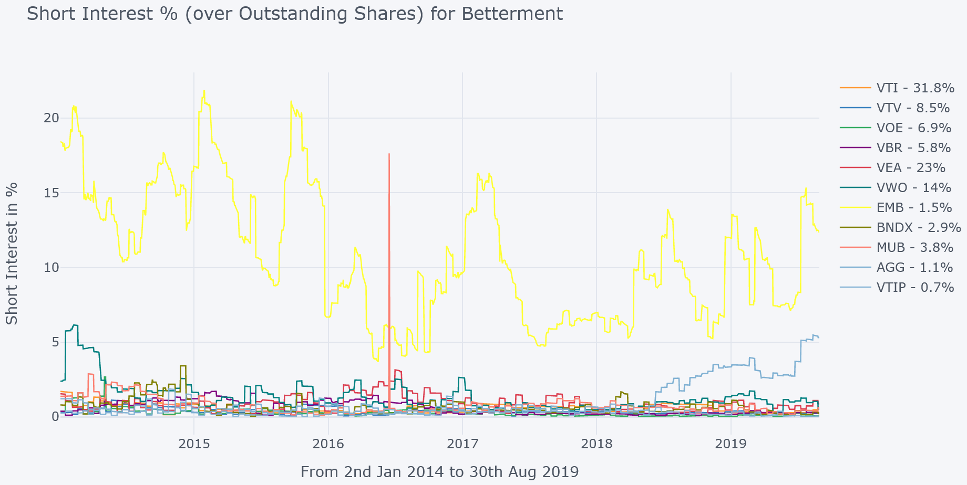
Average: 1.6%

WiseBanyan

Figure E-3: Short Interest for WestBanyan
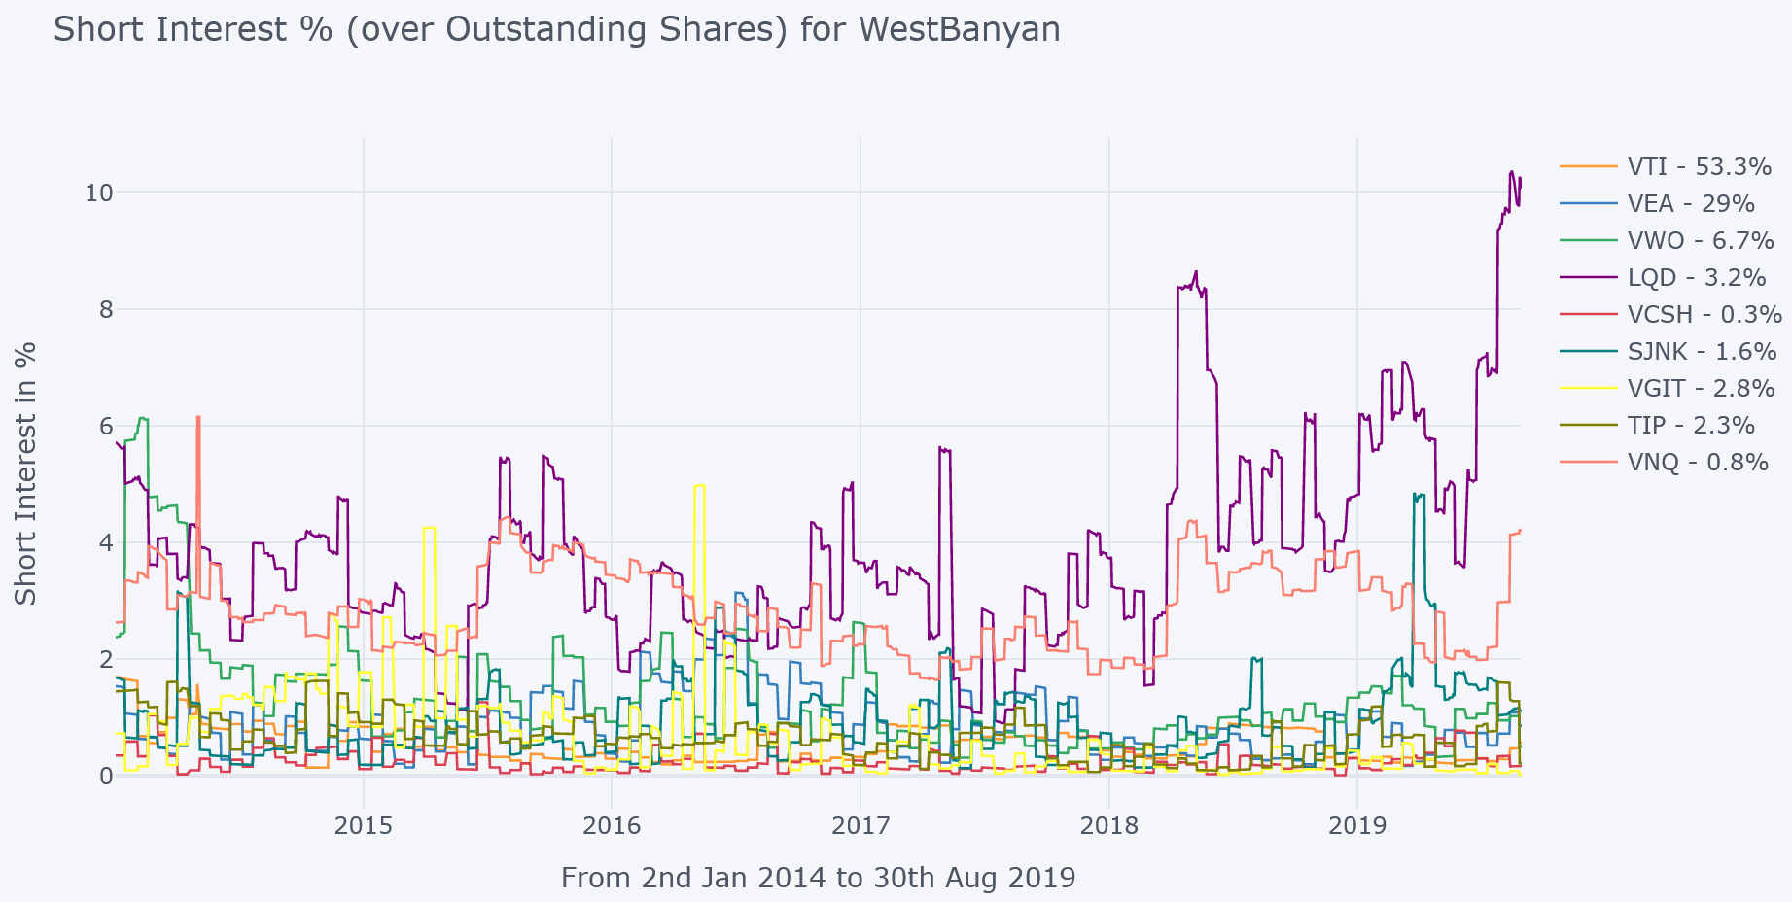
Average: 1.01%

SigFig

Figure E-3: Short Interest for SigFig
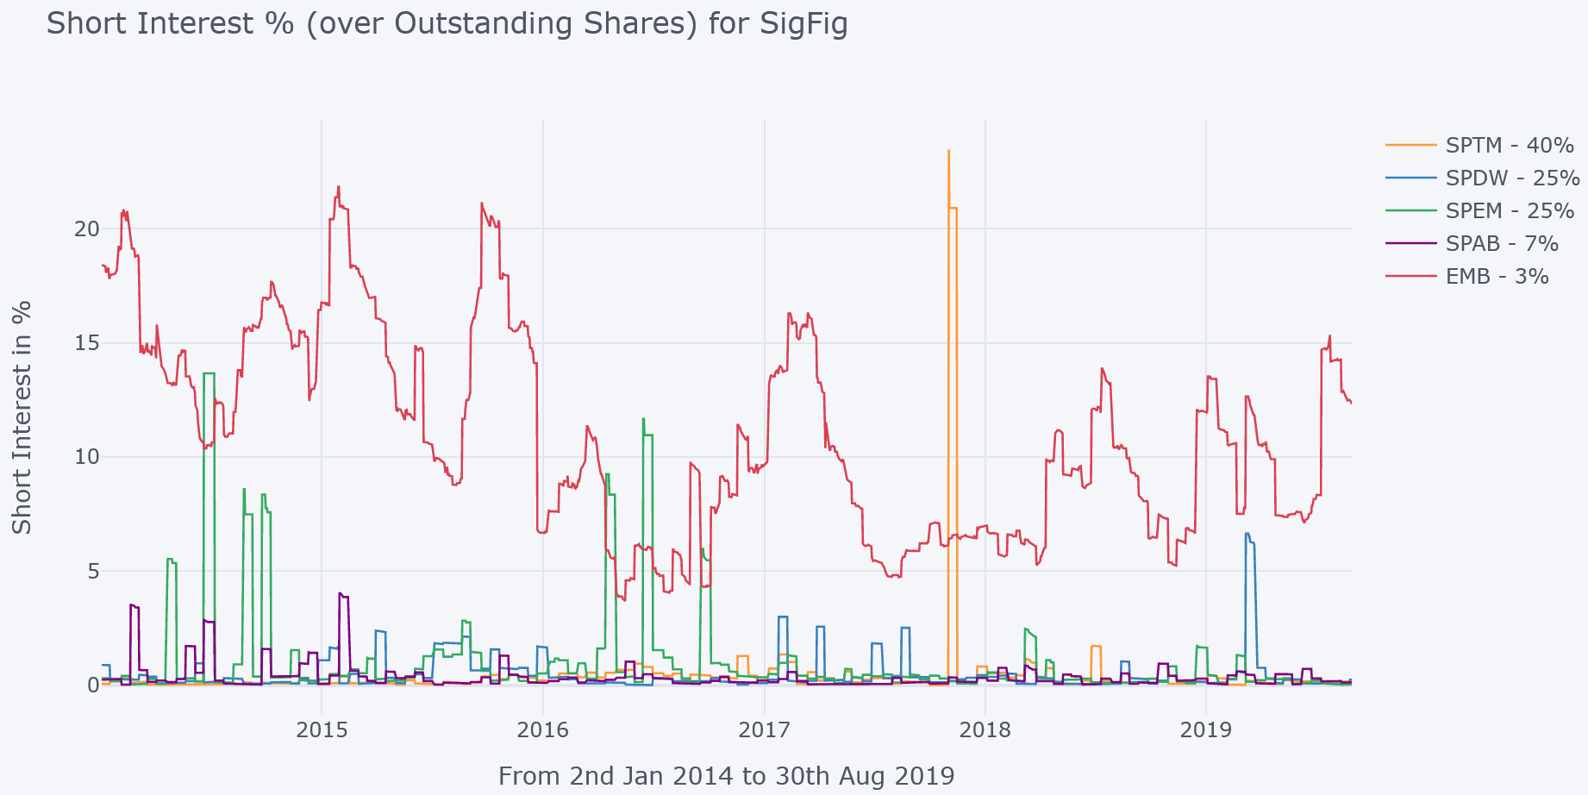
Average: 2.6%

David Brown, Shaun Davies, Matthew Ringgenberg. ‘ETH Arbitrage and Returns Predictability’, 2016
https://www.investopedia.com/articles/mutualfund/05/062705.asp
https://www.investopedia.com/articles/investing/032615/how-etf-arbitrage-works.asp
https://www.etf.com/sections/features-and-news/etfs-highest-lowest-trading-spreads

