Lengnick (2013) Baseline Macro Model – Summary

1. Introduction:
Lengnick (2013) looks to compare an agent-based macro model to the dynamic stochastic general equilibrium approach widely used in traditional macroeconomic equilibrium theory. Lengnick (2013) criticises the dynamics of mainstream macroeconomic models, such as in pricing, which is determined before transactions take place. This is a clear contrast to in real world markets where the price is determined as the result of transactions. The author also suggests that agents typically have rational expectations in a lot of mainstream macroeconomic models. This is unrealistic as human beings do not possess full knowledge on how all other agents will react to any situation. Behavioural factors such as herding are also present in real life and are often absent from macroeconomic theories. This paper suggests that an agent-based macro model is an appropriate response to the criticisms of the DSGE model due to their ability to use a probe to capture ‘emergent’ phenomena from the individual interactions of agents (microfoundations).

The Lengnick model focuses on abstract parts of a full economy with two types of agents, households and firms. Households purchase goods from firms and provide labour to a firm to produce goods in exchange for income. Time is scaled by days and months to allow events to take place and transactions occur between individuals on each day, who have a local knowledge on variables like prices and wages. his model focuses on a market economy, where production and growth are
fixed. Goods are traded daily over a 21-day month and labour is bought monthly. Firms and households are fixed, meaning that they cannot enter or exit the market.

There are 2 types of connections between households and firms. A type A connection creates a link between households and firms for buying goods and type B connections create a link between households and firms for employment. Each household is allowed 7 type A connections and 1 type B connection. Agents can also search for new connections in order to improve their trading efficiency. The properties of each type of agent are listed in Table A below.

Table A – Agent Properties:
Household (N = 1000) | Firm (N = 100)
ID (Integer) | ID (Integer)
Reservation wage, $w_{h}$ (Double) | Wage, $w_{f}$ (Double)
Liquidity, $m_{h}$ (Double) | Liquidity, $m_{f}$ (Double)
Consumption expenditure, $c_{h}^{r}$ (Integer) | Inventory, $i_{f}$ (Integer)
Type B connection (Integer) | Inventory lower bound, upper bound (Integer)
Type A connection (Integer) | Price, $p_{f}$ (Double)
Employed (Boolean) | Price lower bound, upper bound (Double)
Consumption parameter $α$ (Integer) | Behavioural parameters from equations 5, 6 and 7. Values listed on page 110 of Lengnick (Double)
 | Marginal cost (Double)
 | Open positions, To Fire, gamma, lambda, number of months with open positions (Integer)
 | Type B (Array list)
 | Type A (Array list)
 | Liquidity buffer (Double)

2. Model Implementation:
This section explains the interactions between agents in the model, referencing the paper using the code for each process. The model is implemented in Java utilising the external library JAS. There are 4 classes:

- Model – The model class is a superclass within the macro model, it is responsible for setting the values of parameters, building the model and running the monthly event loop.
- Observer – Outputs graphics in the JAS interface to help us track how variables change over time.
- Firm – Establishes the parameters for firm agents, their values are called and set from this class.
- Household – Establishes the parameters for household agents, their values are called and set from this class.

2.1 Monthly Loop:
The monthly events can be found within the ‘scheduleEvents’ subroutine in the Model class. These events are split into 3 categories based on their frequency, including events that occur at the beginning of the month, events that occur daily and events that occur at the end of the month.

2.1.1 Beginning of Month Events:
- Set new firm wage, following equation (5) in Lengnick.
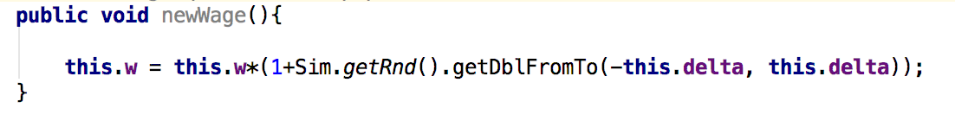
- The decision over whether to change the price or number of employees is based on updating firm inventory range, following equations (6) and (7) in Lengnick.
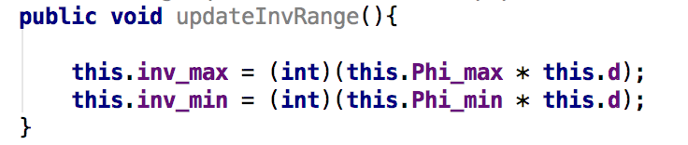
- Update firm price range, based on 2 behavioural variables and the marginal cost following equations (8) and (9) in Lengnick.
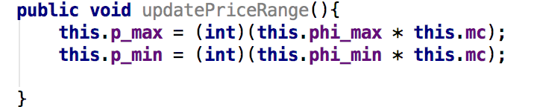

- Update firm demand for labour and change price. Prices are raised if the current inventories are lower than the lower bound and the current price doesn’t exceed the upper bound. If current inventory is below the lower bound then a vacancy is opened, if it is above the upper bound then a worker is fired.
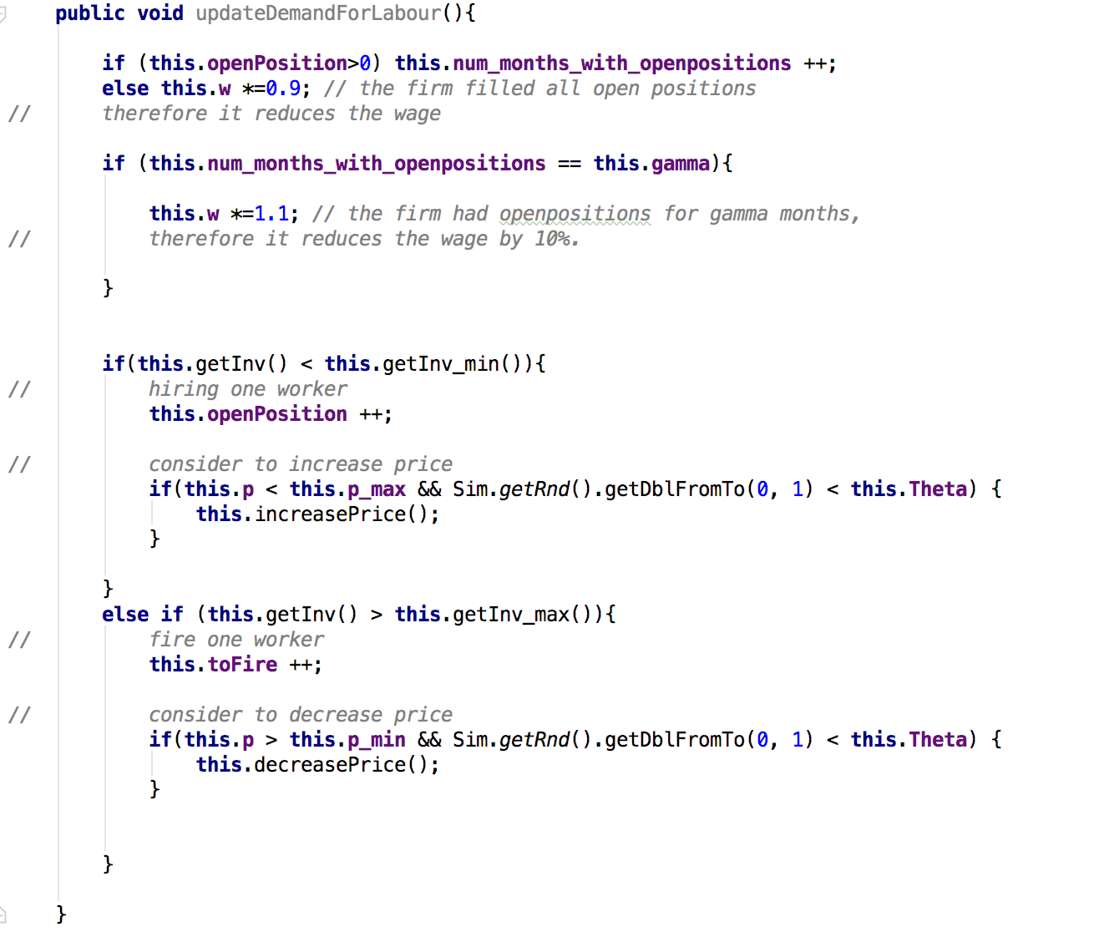
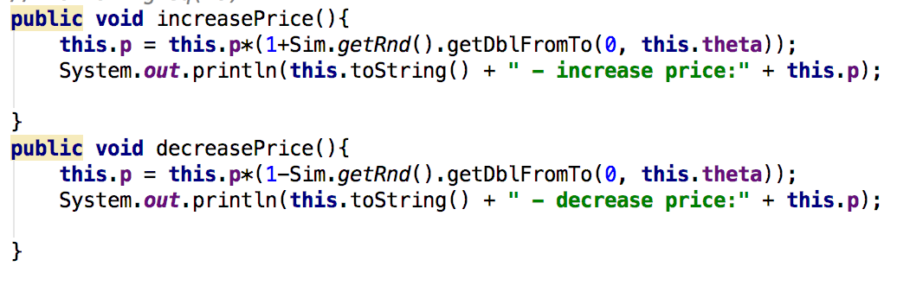

- Update household type A connections based on price. Household searches for a more beneficial trading connection by randomly picking a firm they have no existing connection with from a subset of all firms and if the price of that firm’s good is a set boundary lower than the price of a firm’s good from an existing connection, the household changes that type A connection to the cheaper firm.
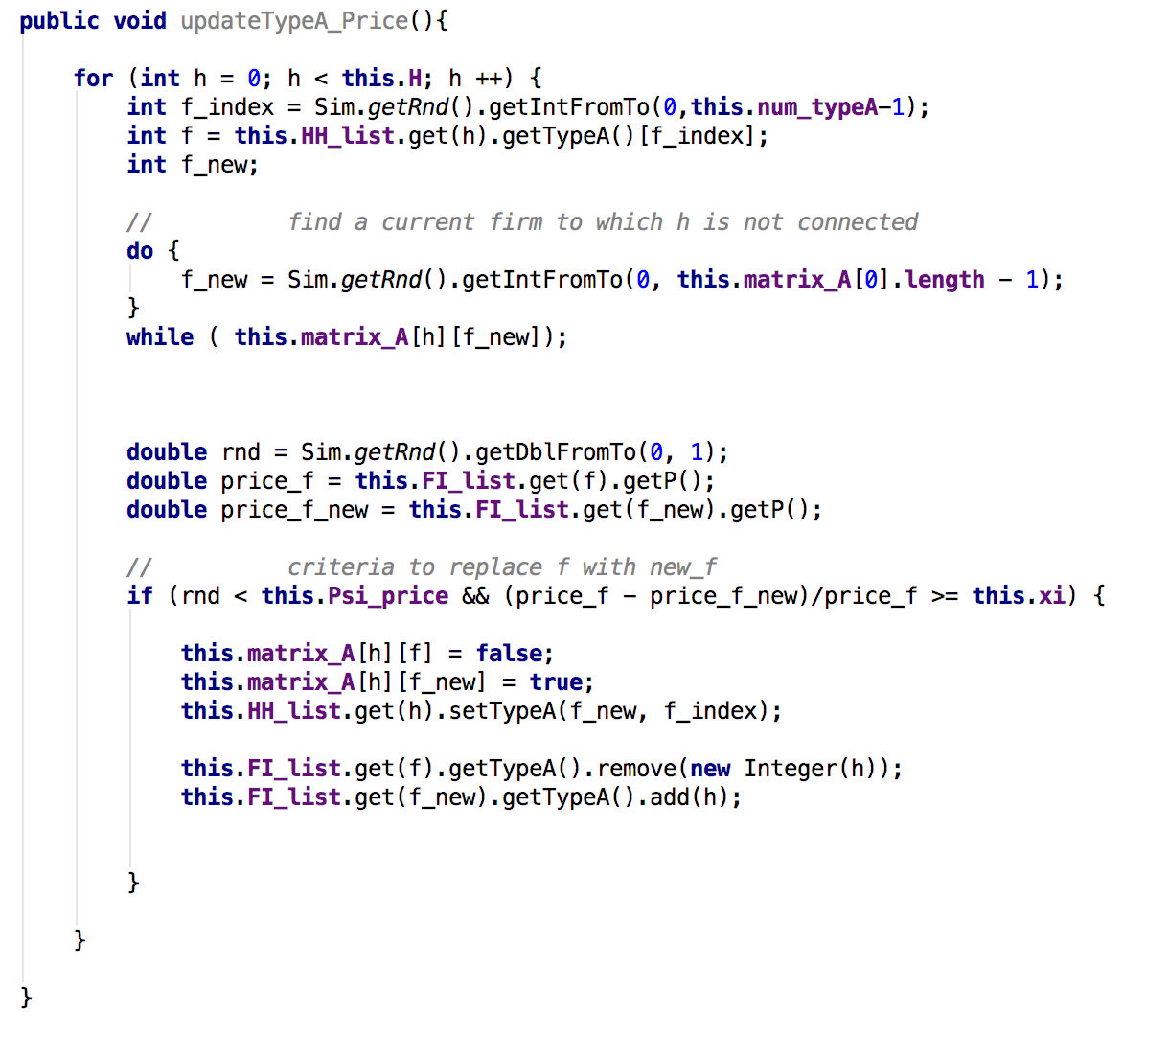

- Update household type A connections based on demand. If the household was demand constrained in the previous month, they can break the connection with the firm that couldn’t satisfy their demand and establish a new type a connection.
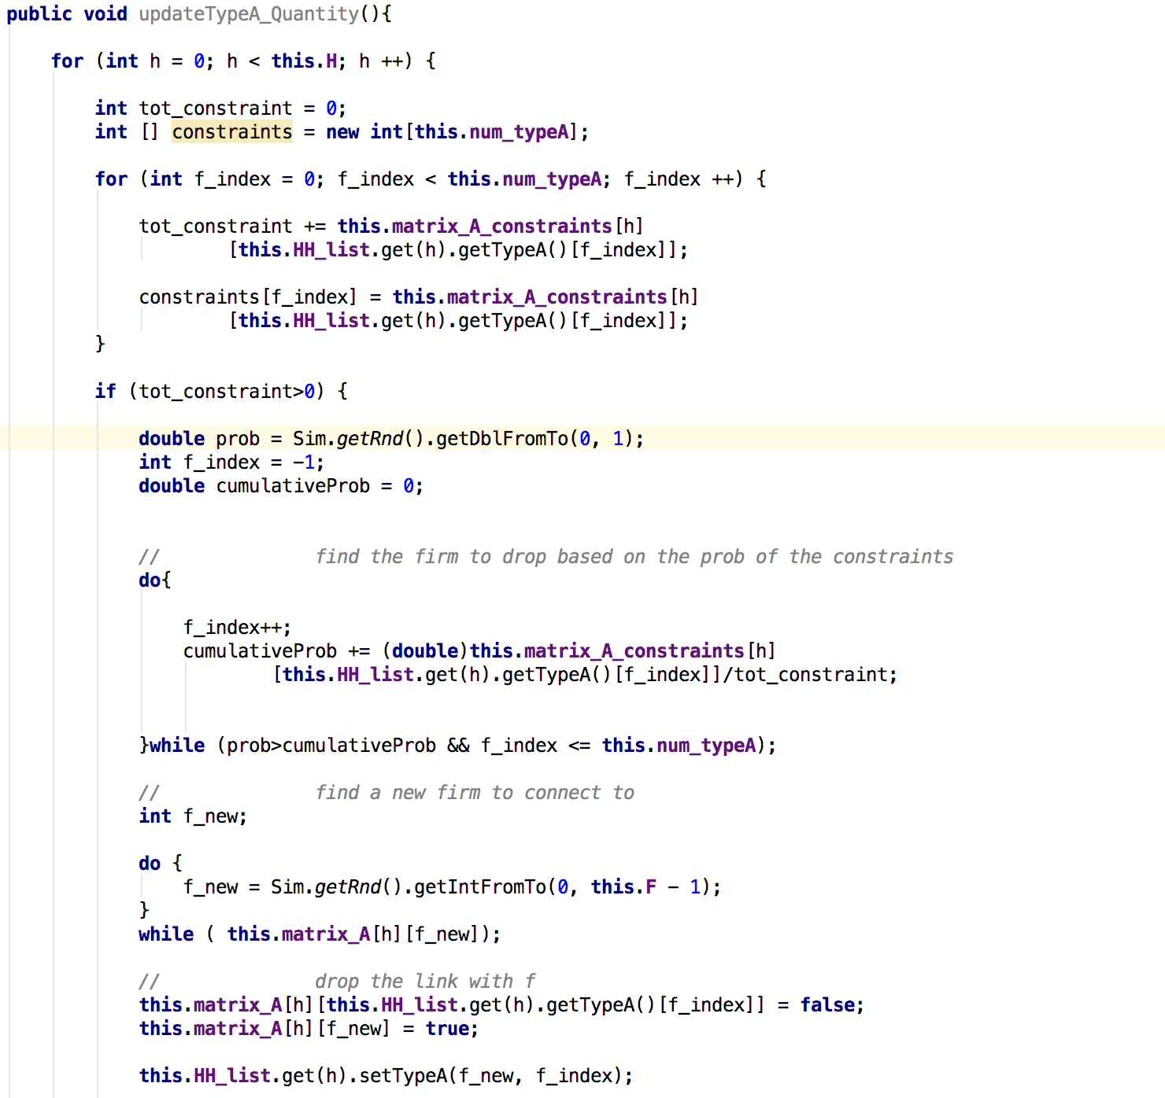
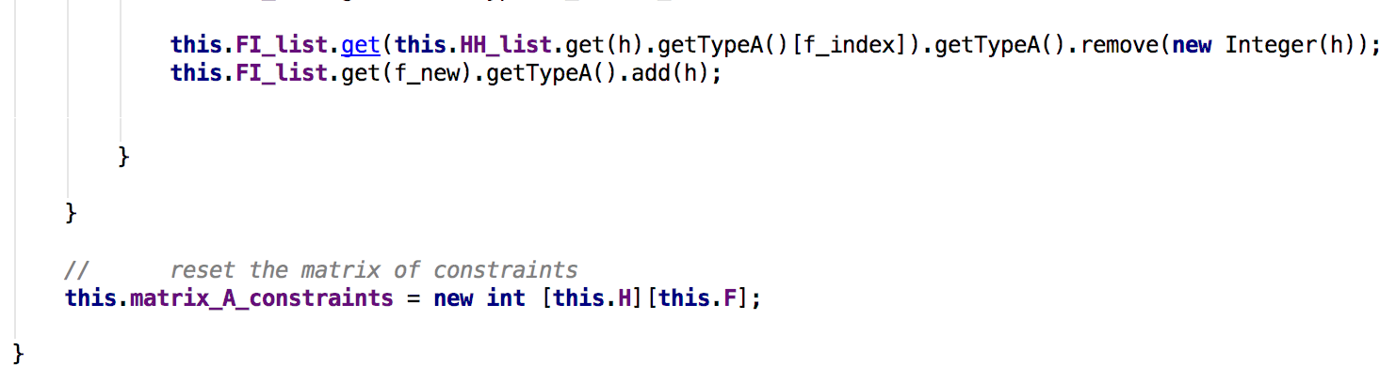
- Update household type B connection. Households that are unemployed randomly search for vacancies at a firm at the beginning of the month. If there is a position open and the wage is higher than their current received wage, a new type b connection is established. Employed households that are working for less than their reservation wage will increase their intensity of searching for a higher paying job that satisfies $w_{f}>w_{h}$. If the firm offers no vacancy or the wage it pays is too small, the search process is repeated until a total of $β$ firms have been visited. Households therefore search for new vacancies at different intensities based on their wage satisfaction.
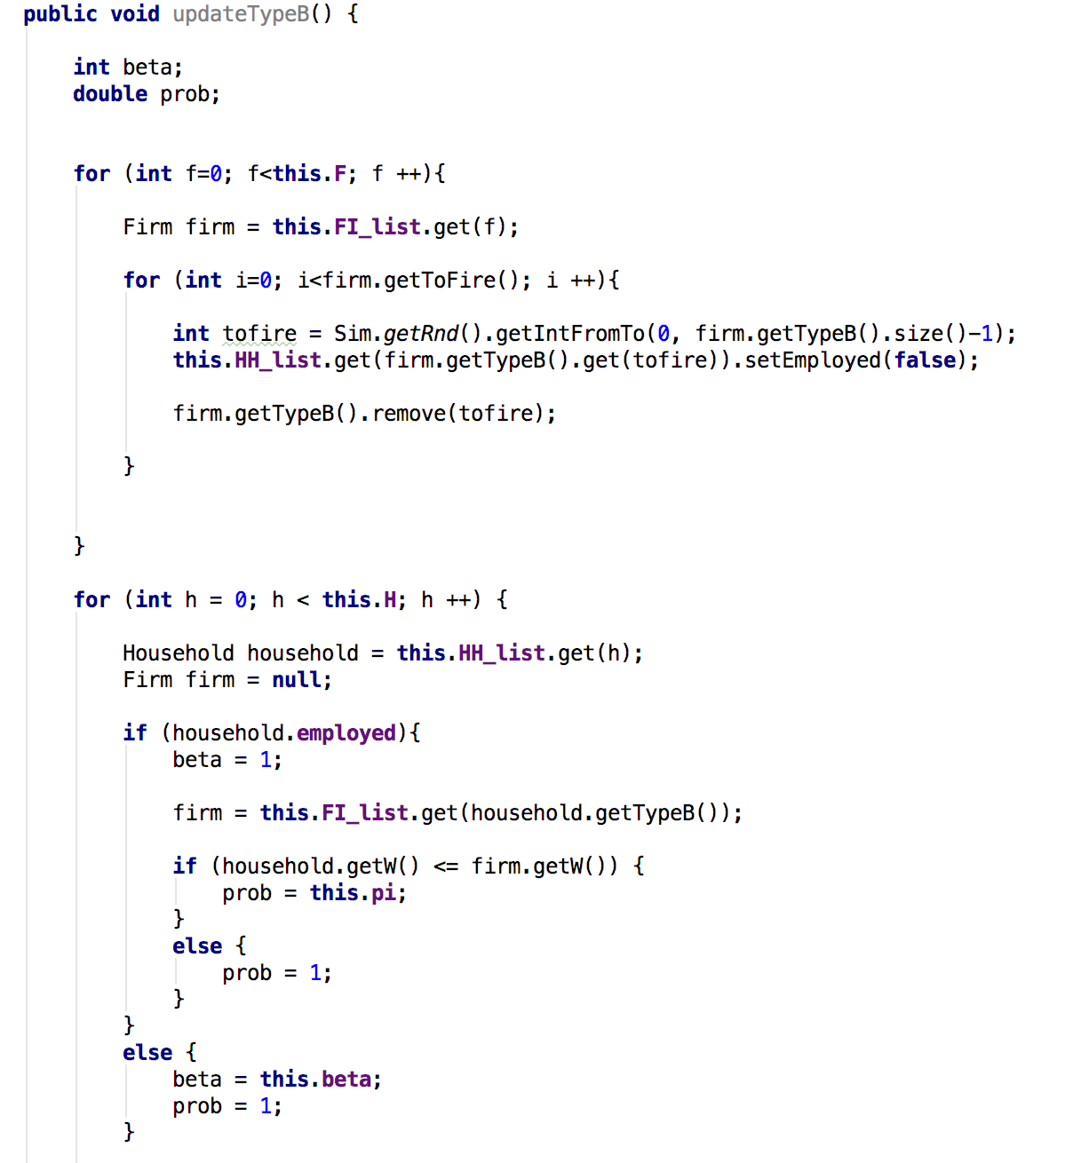
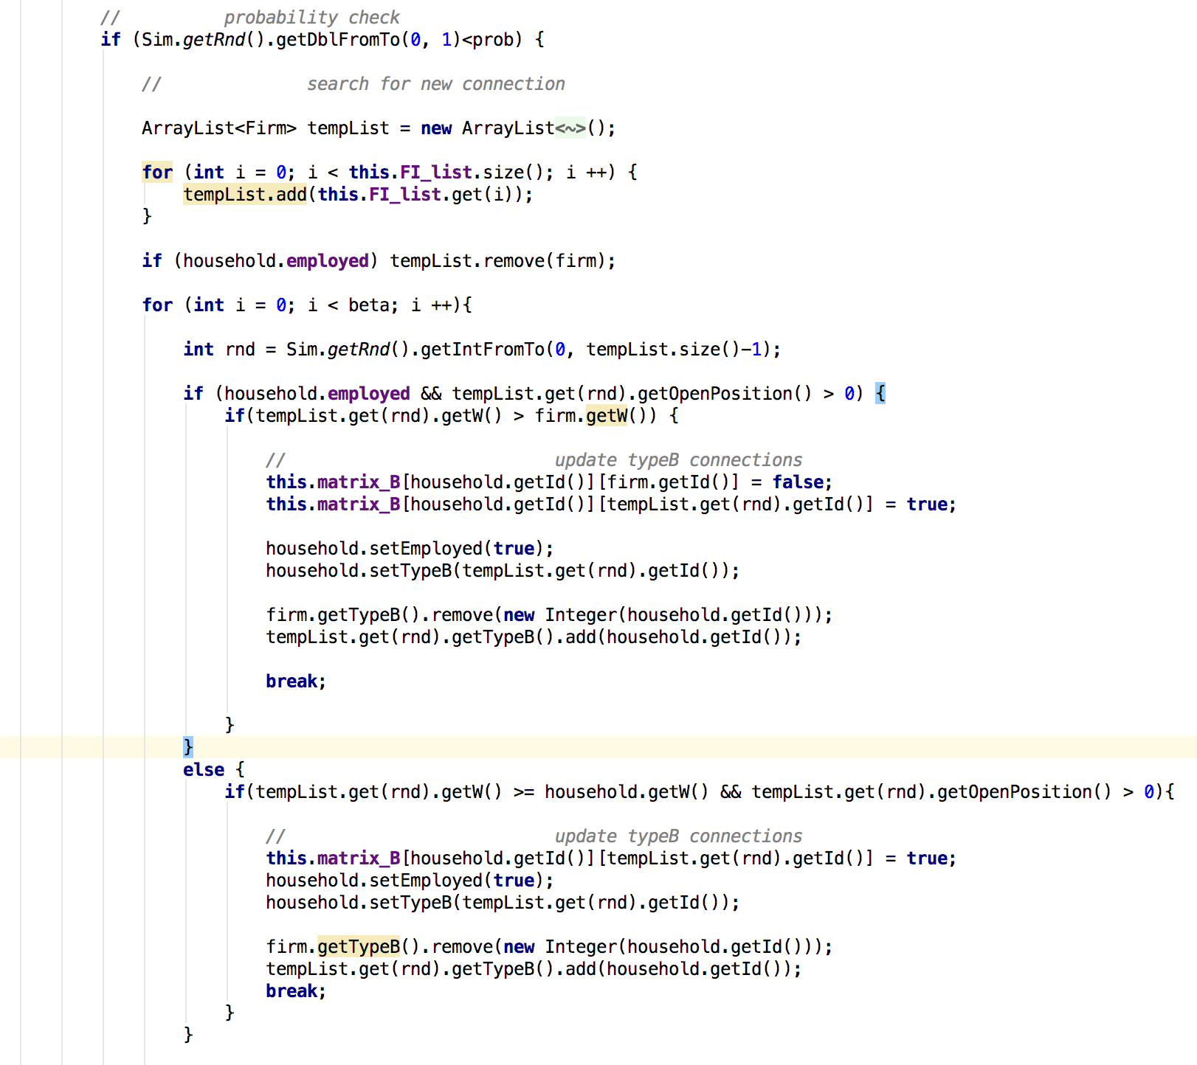
- Update household average price.
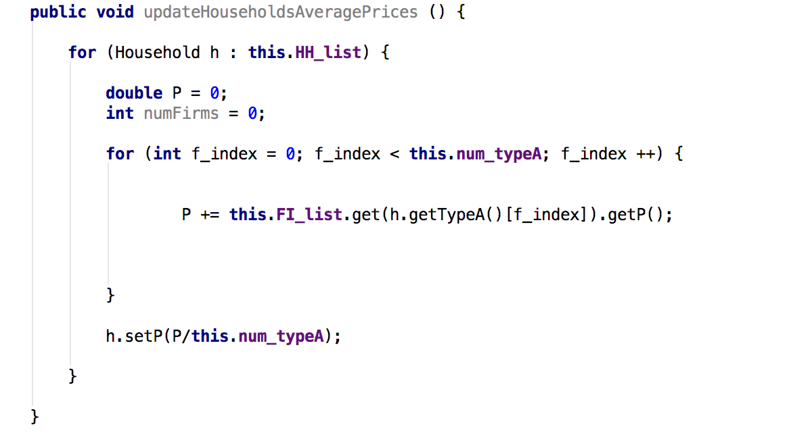

2.1.2 Daily Events:
- Good purchases. Household demand for each day is evenly distributed throughout the month and based on consumption expenditure. Each household visits a firm that they have a type a connection with and if inventories are high enough and the household has enough liquidity to pay for the goods, a transaction takes place. These variables are then adjusted and the firm’s liquidity increases from the sale. If there is a demand or supply constraint, then the transaction is carried out at the highest possible amount of inventory.
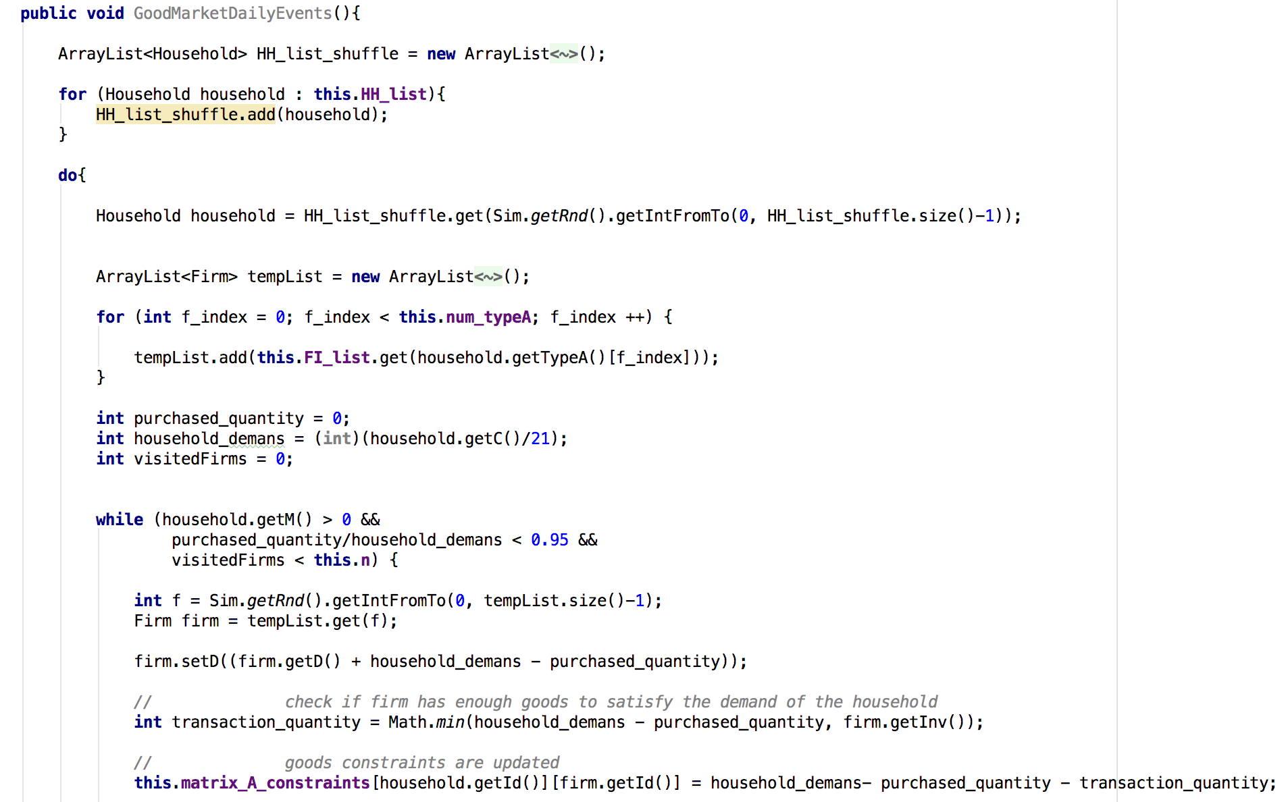
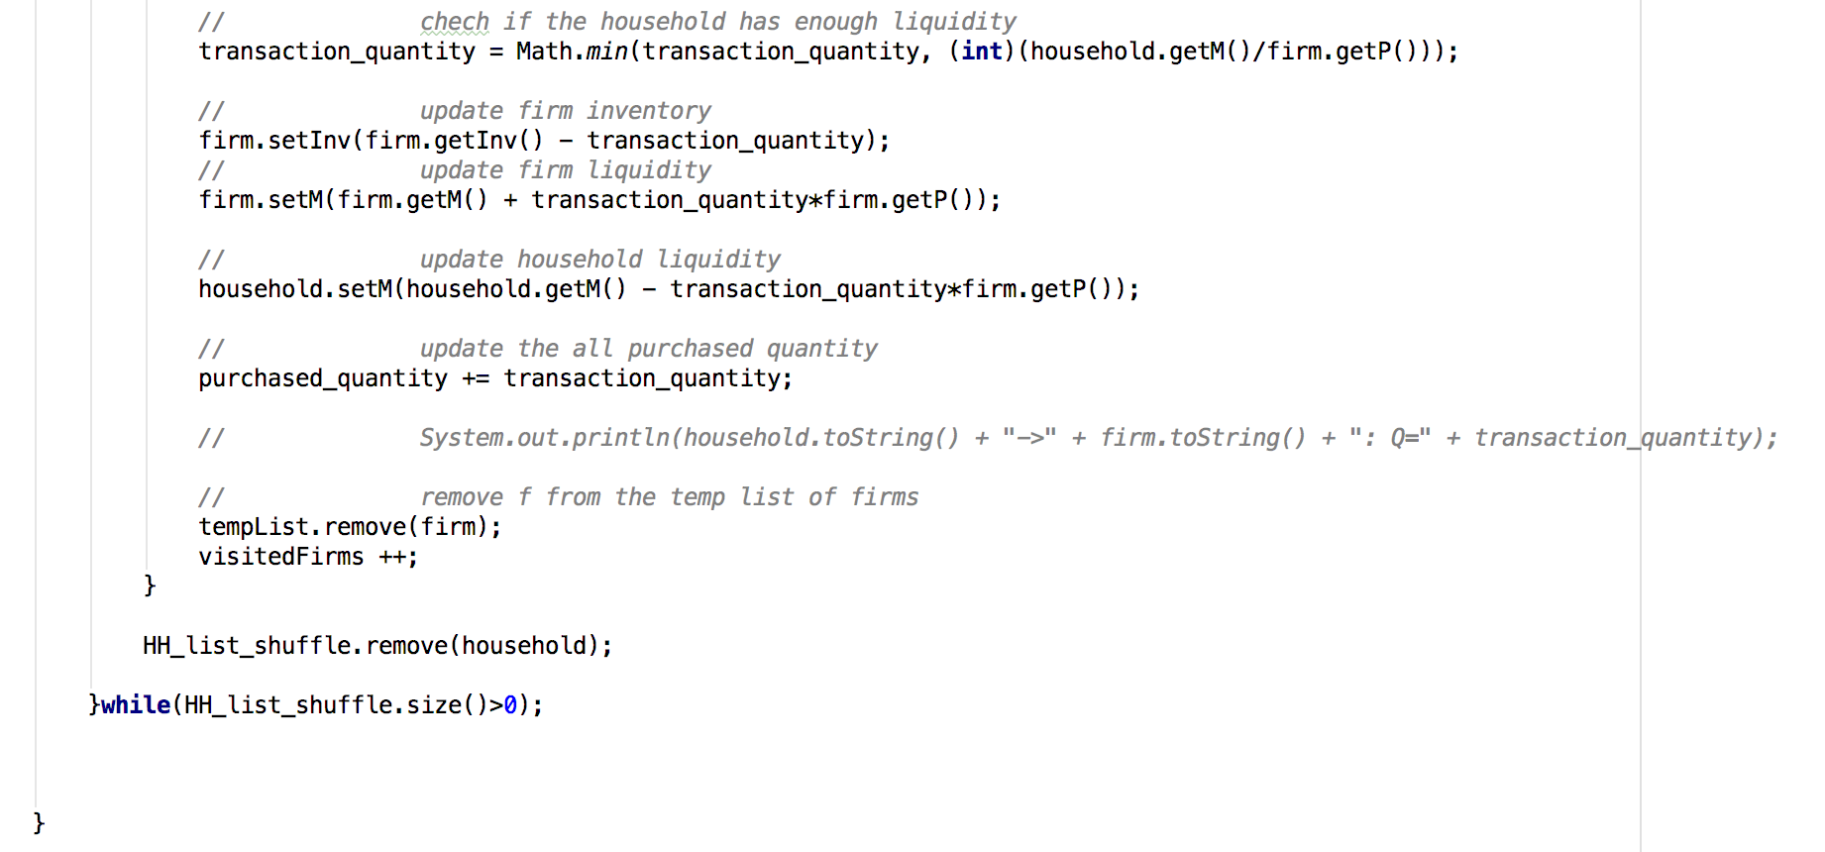
- Firm production, following equations (13) and (14) in Lengnick.
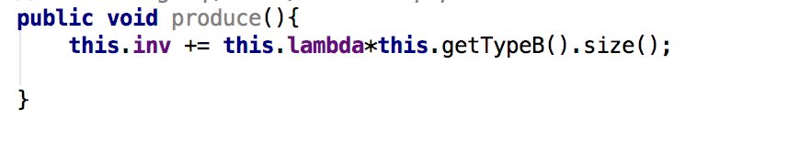

2.1.3 End of Month Events:
- Firms pay wages to households using their liquidity and liquidity buffer if the firm makes a loss. In the event that a loss is so large that this is not enough to pay wages, employees accept a wage cut in order to avoid firms exiting the market.
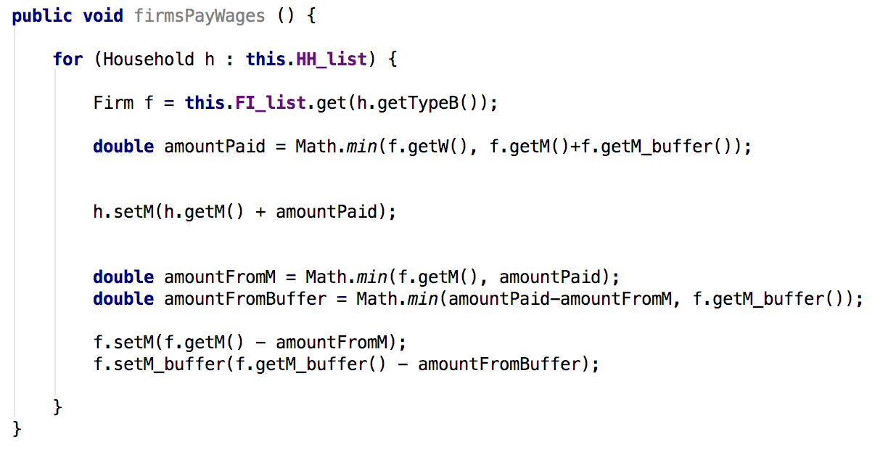
- Firms pay profits to households. If a firm has liquidity remaining after paying wages, then a fraction of this amount is kept as a liquidity buffer for months where the firm incurs losses. The rest is distributed among households as profit, which is used as a proxy for stock ownership. The amount of profit a household receives depends on their current liquidity, meaning that richer households receive a greater amount of profit. If a firm makes a loss in a given month, the firm does not make any profit and uses their liquidity buffer to pay wages.
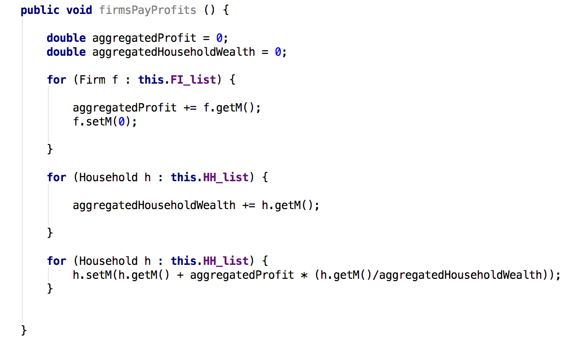

3. Simulation Results:
Lengnick (2013) runs a simulation for 6000 months plus a burn-in of 1000 months. Unsatisfied demand and unemployment is measured to see if the economy converges to an equilibrium without the presence of market clearing. The amount of unsatisfied demand at the end of the simulation is very small and unemployment is very low. The baseline model therefore has the ability to self-organise and reflects a realistic level of unemployment, showing that the individual actions of agents can lead to efficient aggregate statistics. These results suggest an emergent property of the baseline macro model.

This paper also reports that the model contains endogenous business cycles through aggregate production, whereas DSGE models impose exogenous shocks on the economy. In the baseline agent-based macroeconomic model, production cycles through below full employment due to failed interactions of agents leading to inefficiency. As a result, shocks are a property of the market economy rather than being exogenous. The model also realistically reproduces aggregate macroeconomic theories such as the Phillips curve and the Beveridge curve.

Lengnick (2013) then examines the effect of monetary policy on the baseline agent-based macroeconomic model, in both the short run and the long run. Established economic theory suggests that an increase in the money supply only increases production in the long term, which the author tests by multiplying the liquidity of all agents before running the simulation and finding that prices increase over 50 years whilst production stays at a relatively similar level, which is consistent with economic theory. In the short-run, a random increase of the money amount in a given month is more effective in increasing output during a recession than during a boom.

Section 5 looks at the impact of small shocks on the model through reducing the demand of one household by 5% in the middle of a particular month. This micro shock has no effect on the structure of the cycle, however in the very long run (over 100 years) a large boom occurs followed by a bust. This contrasts the theory of exogenous shocks within DSGE models by introducing a shock through microfoundations. The speed of the business cycle is also found to depend on the population size, meaning that a smaller number of households create a boom much faster than the standard baseline model.

Lengnick (2013) concludes that the baseline model can replicate widely accepted macroeconomic theories that emerge endogenously from the individual interactions of agents. All actions take place on the micro level, therefore the baseline model has microfoundations as opposed to DSGE models. The author concludes that agent-based computational macroeconomic models have the potential to offer an alternative to DSGE models.

